Major Project
On
Water Potability prediction with ML models
Submitted for partial fulfillment for the requirements on
the award of
Bachelor of Computer Applications
Under the guidance of Mr. Tanishq Malik

KAMAL INSTITUTE OF HIGHER EDUCATION
AND ADVANCED TECHNOLOGY
(Affiliated to GGSIPU, DELHI) K-1,
Extension Mohan Garden,
New Delhi
110059

ACKNOWLEDGEMENT

We would like to express our heartfelt gratitude to Mr. Tanishq Malik, our project guide, for her invaluable guidance, encouragement, and support throughout the completion of our minor project. Her constant supervision and insightful suggestions helped us to enhance our understanding and successfully accomplish our objectives.

We are also thankful to the faculty and management of Kamal Institute of Higher Education and Advance Technology, affiliated to Guru Gobind Singh Indraprastha University (GGSIPU), Mohan Garden, for providing us with the necessary facilities, resources, and a conducive environment for learning and research.

We would like to extend our sincere appreciation to all those who directly or indirectly contributed to the successful completion of this project.

Lastly, we wish to acknowledge the hard work, cooperation, and team spirit of all our group members — Abhishek Kumar, Aniket Dubey, Layana Gupta, and Harsh Bhardwaj— for their dedication and efforts in bringing this project to fruition.

Group Members:
Abhishek Kumar
Aniket Dubey
Lavanya Gupta
Harsh Bhardwaj

Institute’s Certificate

This is to certify that the minor project titled “Water potability ML Prediction Model with Dashboard” has been successfully completed and submitted by Abhishek Kumar, Aniket Dubey, Lavanya Gupta, and Harsh Bhardwaj, students of Kamal Institute of Higher Education and Advance Technology, affiliated to Guru Gobind Singh Indraprastha University (GGSIPU), New Delhi, in partial fulfilment of the requirements for the award of the degree of Bachelor of Computer Applications (BCA).

This project has been carried out under the guidance and supervision of Mr. Tanishq Malik, Kamal Institute of Higher Education and Advance Technology.

The work embodied in this project is an original piece of research carried out by the above-mentioned students and has not been submitted to any other university or institution for the award of any degree or diploma.

Project Guide
Mr. Tanishq Malik
Signature: __________________________
Date: _____________

DECLARATION

We, the undersigned students of Kamal Institute of Higher Education and Advance Technology, affiliated to Guru Gobind Singh Indraprastha University (GGSIPU), New Delhi, hereby declare that the major project titled “Water potability ML Prediction Model with Dashboard” is an original work carried out by us under the guidance of Mr. Tanishq Malik

We further declare that this project report has not been submitted to any other university or institution for the award of any degree or diploma. All information and data used in this project have been acknowledged and referenced properly to the best of our knowledge.

Guided By:
Mr. Tanishq Malik
Signature: _____________
Date: _____________

Group Members:
Abhishek kumar
Aniket Dubey
Lavanya Gupta
Harsh Bharadwaj

Water Potability Prediction Using Machine Learning and Dashboard
SYNOPSIS

INTRODUCTION
Water is one of the most essential natural resources required for the survival of all living organisms on Earth. It is fundamental to life and plays a vital role in sustaining human health, agriculture, industry, and environmental balance. Every living being depends on water for various biological processes, and its availability directly impacts the quality of life. In addition to drinking, water is extensively used in food production, sanitation, manufacturing, and energy generation. Therefore, ensuring the availability of clean and safe water is one of the most important global challenges.
Despite its importance, access to safe and potable drinking water remains a major issue in many parts of the world. According to various global studies, a significant portion of the population still relies on contaminated water sources, which leads to severe health risks. Waterborne diseases such as cholera, typhoid, diarrhoea, and dysentery are commonly caused due to the consumption of unsafe water. These diseases not only affect individual health but also create a burden on healthcare systems and hinder socio-economic development.
In recent years, rapid industrialization and urbanization have significantly contributed to the deterioration of water quality. Industries discharge harmful chemicals and waste materials into water bodies, while urban areas generate large amounts of sewage and pollutants. Agricultural activities also add to the problem through the use of fertilizers and pesticides, which often seep into groundwater and nearby water sources. As a result, water resources are increasingly being contaminated with toxic substances such as heavy metals, organic pollutants, and microbial contaminants.
Another major factor affecting water quality is population growth. As the population increases, the demand for clean water also rises. This leads to over-exploitation of natural water resources and increases the risk of contamination. In many regions, the lack of proper water management systems and infrastructure further worsens the situation. Therefore, monitoring and maintaining water quality has become a critical task for governments, organizations, and researchers.
Traditionally, water quality testing is carried out in laboratories using chemical and biological analysis techniques. Although these methods are accurate, they have several limitations. They are time-consuming, expensive, and require skilled professionals to perform the analysis. Moreover, these methods are not suitable for real-time monitoring, which is essential for taking immediate action in case of contamination. In remote or rural areas, access to such testing facilities is often limited, making it difficult to ensure safe drinking water.
With advancements in technology, there is a growing need for faster, cost-effective, and automated solutions for water quality assessment. This is where Machine Learning (ML) plays a significant role. Machine learning is a branch of artificial intelligence that enables systems to learn from data and make predictions or decisions without being explicitly programmed. By analysing historical data, machine learning models can identify patterns and relationships between different parameters and use this knowledge to make accurate predictions.
In the context of water quality prediction, machine learning models can analyse various physicochemical parameters such as pH, hardness, solids, chloramines, sulfate, conductivity, organic carbon, trihalomethanes, and turbidity. These parameters are crucial indicators of water quality and can help determine whether water is safe for drinking. By feeding this data into machine learning algorithms, the system can classify water as potable or non-potable with a high degree of accuracy.
The use of machine learning in this domain offers several advantages. It reduces the need for manual testing, saves time and cost, and provides quick results. Additionally, machine learning models can handle large datasets and improve their performance over time as more data becomes available. This makes them highly suitable for real-world applications where continuous monitoring and analysis are required.
In this project, a machine learning-based system has been developed to predict water potability. Various algorithms such as Decision Tree, Random Forest, K-Nearest Neighbours (KNN), and Support Vector Machine (SVM) have been implemented and compared to determine the most effective model. The system uses a dataset containing water quality parameters and processes it through different stages, including data preprocessing, feature selection, model training, and evaluation.
The objective of this project is not only to build an accurate prediction model but also to demonstrate the practical application of machine learning in solving environmental problems. By providing a fast and reliable method for water quality assessment, this system can support decision-making and contribute to better water management practices.
In conclusion, ensuring access to safe drinking water is a critical global challenge, and innovative solutions are required to address it effectively. Machine learning provides a powerful tool for analyzing water quality data and generating accurate predictions. The integration of such technologies can significantly improve the efficiency and effectiveness of water quality monitoring systems, thereby contributing to public health and environmental sustainability.

PROBLEM STATEMENT
Water contamination has emerged as a critical global issue that affects millions of people across the world. Access to safe and clean drinking water is a basic human necessity, yet a significant portion of the population continues to rely on polluted water sources. Contaminated water is a major cause of various waterborne diseases such as cholera, typhoid, diarrhea, and hepatitis, which lead to severe health complications and even death in extreme cases. This problem is particularly severe in developing countries and rural areas where proper water treatment and monitoring systems are not easily available.
The quality of water is influenced by multiple factors, including industrial waste discharge, agricultural runoff, urban sewage, and natural environmental changes. Harmful substances such as heavy metals, chemicals, and microorganisms enter water bodies, making them unsafe for human consumption. Therefore, it is essential to continuously monitor water quality to ensure safety and prevent health risks. However, achieving this level of monitoring using traditional methods presents several challenges.
Conventional water quality testing methods primarily rely on laboratory-based analysis. These methods involve collecting water samples and conducting detailed chemical and biological tests using specialized equipment. While these techniques are highly accurate, they suffer from multiple limitations. One of the major drawbacks is that they are time-consuming, as the testing process can take several hours or even days to produce results. This delay can be critical, especially in situations where immediate action is required to prevent the consumption of contaminated water.
Another significant limitation is the high operational cost associated with laboratory testing. The need for expensive equipment, chemicals, and trained professionals makes these methods costly and less feasible for large-scale or continuous monitoring. Additionally, such facilities are often concentrated in urban areas, making them inaccessible to rural and remote regions where water contamination issues are often more severe. This lack of accessibility further increases the risk of people consuming unsafe water due to the absence of timely testing.
Moreover, traditional methods do not support real-time monitoring, which is essential for identifying sudden changes in water quality. The delay in obtaining results reduces the effectiveness of these methods in providing quick and actionable insights. As a result, there is a growing need for an alternative solution that can overcome these limitations and provide faster, cost-effective, and reliable water quality assessment.
To address these challenges, the development of an automated system based on modern technologies is necessary. Machine Learning (ML) offers a promising solution to this problem. By analyzing historical water quality data, machine learning algorithms can identify patterns and relationships between various parameters and predict the potability of water. This approach enables faster decision-making and reduces dependency on manual testing procedures.
The primary objective of this project is to design and develop a machine learning-based system that can predict whether water is safe for drinking based on its quality parameters. The system takes input features such as pH, hardness, solids, chloramines, sulfate, conductivity, organic carbon, trihalomethanes, and turbidity, and processes them using different machine learning models to generate accurate predictions. By comparing the performance of multiple algorithms, the system identifies the most efficient model for this task.
In conclusion, the problem of water contamination requires an efficient and scalable solution that can provide quick and accurate results. The limitations of traditional methods highlight the need for technological intervention. This project aims to address these issues by implementing a machine learning-based approach, which can significantly improve the process of water quality assessment and contribute to better public health and environmental management.

WHY THIS TOPIC IS CHOSEN
The selection of the project topic “Water Potability Prediction using Machine Learning” is based on its high relevance, real-world importance, and practical applicability in solving one of the most critical global challenges. Water is a fundamental necessity for life, and ensuring its quality is essential for maintaining human health, supporting economic activities, and preserving environmental balance. The growing concerns regarding water contamination and limited access to safe drinking water make this topic highly significant and impactful.

🔹 Health Importance
One of the primary reasons for choosing this topic is its direct connection to human health. Clean and safe drinking water is essential for preventing diseases and ensuring a healthy life. However, contaminated water remains a major cause of illness worldwide, especially in developing regions.
Unsafe drinking water can lead to serious waterborne diseases such as:
- Cholera
- Typhoid
- Diarrhea
- Dysentery
These diseases are often caused by the presence of harmful microorganisms, chemicals, or pollutants in water. In many cases, people are unaware of the quality of the water they consume, which increases the risk of infections and long-term health issues. Children and elderly individuals are particularly vulnerable to such diseases.
An efficient water quality prediction system can help in early detection of contamination, enabling preventive measures before the water is consumed. By using machine learning techniques, it becomes possible to analyse water parameters and predict potability quickly and accurately. This can significantly reduce health risks and improve the overall quality of life.

🔹 Environmental Importance
Water is not only important for human use but also plays a vital role in maintaining ecological balance. Rivers, lakes, and groundwater sources support a wide range of aquatic life, including plants, fish, and microorganisms. When water becomes polluted, it disrupts these ecosystems and can lead to the loss of biodiversity.
Industrial waste, agricultural runoff, and improper waste disposal contribute to environmental pollution. Toxic substances such as heavy metals and chemicals accumulate in water bodies, affecting aquatic organisms and entering the food chain. Over time, this can cause irreversible damage to ecosystems.
Monitoring water quality is essential for protecting natural resources and ensuring sustainable development. This project contributes to environmental conservation by providing a tool that can help identify contamination and support timely intervention. By predicting water quality, appropriate measures can be taken to prevent environmental degradation and protect aquatic life.

🔹 Technological Importance
Another major reason for selecting this topic is the opportunity to apply modern technological solutions to real-world problems. Machine Learning (ML), a branch of Artificial Intelligence, has revolutionized the way data is analysed and decisions are made. It enables systems to learn from data, identify patterns, and make predictions with minimal human intervention.
In the context of water quality analysis, machine learning provides a powerful approach to handle large datasets and complex relationships between different parameters. Traditional methods of water testing are limited in terms of speed and scalability, whereas ML models can process data quickly and provide instant predictions.
This project demonstrates the practical application of machine learning algorithms such as Decision Tree, Random Forest, K-Nearest Neighbors (KNN), and Support Vector Machine (SVM). Among these, SVM has shown high accuracy, highlighting the effectiveness of ML techniques in environmental applications. The use of such advanced technologies makes the system efficient, reliable, and scalable.

🔹 Practical Applications
The project has wide-ranging practical applications across multiple sectors. The developed system can be used by:
- Industries – to monitor water used in manufacturing processes
- Water Treatment Plants – to assess water quality before distribution
- Government Organizations – to ensure public health and safety
- Environmental Agencies – to monitor pollution levels and take corrective actions
In addition, the system can be useful for individuals who want to check the quality of water in their local areas. By providing fast and accurate predictions, the system reduces reliance on traditional laboratory testing methods and supports better decision-making.

🔹 Economic Importance
Water quality has a direct impact on economic development. Industries require clean water for production, agriculture depends on water for irrigation, and urban areas need a reliable water supply for daily activities. Poor water quality can lead to reduced productivity, increased healthcare costs, and economic losses.
For example, contaminated water in agriculture can affect crop yield and food quality, leading to financial losses for farmers. Similarly, industries may face operational challenges if water quality is not maintained. By implementing an efficient prediction system, organizations can reduce costs associated with testing and prevent losses caused by poor water quality.

🔹 Need for Automation and Efficiency
Traditional water testing methods are not only time-consuming but also require skilled professionals and expensive equipment. In many rural and remote areas, such facilities are not available, making it difficult to ensure safe drinking water.
There is a strong need for automated systems that can provide quick, accurate, and cost-effective solutions. Machine learning-based systems fulfill this requirement by offering real-time or near real-time predictions. This improves efficiency and allows faster response to potential contamination issues.

🔹 Research and Learning Perspective
From an academic perspective, this topic provides an excellent opportunity to explore and apply concepts of data science and machine learning. It involves various stages such as data collection, preprocessing, model training, evaluation, and optimization. This helps in developing a deeper understanding of how machine learning can be used to solve practical problems.
The project also enhances technical skills related to programming, data analysis, and model development. It encourages critical thinking and problem-solving, which are essential for a career in the field of computer applications and data science.

🔹 Conclusion
In conclusion, the topic has been chosen due to its high relevance, real-world impact, and technological significance. It addresses a critical global issue by providing an efficient solution for water quality prediction. The integration of machine learning techniques not only improves accuracy and speed but also opens new possibilities for innovation in environmental monitoring.
This project successfully combines health, environmental, economic, and technological aspects, making it a well-rounded and meaningful study. It demonstrates how modern technology can be used to solve real-world problems and contribute to sustainable.

OBJECTIVE AND SCOPE
Objective
The primary objective of this project is to design and implement a Machine Learning-based system that can accurately predict the potability of water based on various quality parameters. Ensuring access to safe drinking water is a critical challenge, and this project aims to provide a technological solution by leveraging the power of machine learning algorithms.
The system is developed to analyse water quality data and determine whether a given water sample is safe for human consumption. To achieve this, the project focuses on building predictive models using historical datasets that contain important physicochemical properties of water. The model processes these parameters and generates a prediction indicating the suitability of water for drinking purposes.
The specific objectives of the project are as follows:
- To analyse water quality data and understand the significance of various parameters affecting potability
- To perform data cleaning and preprocessing techniques such as handling missing values and normalization
- To apply multiple machine learning algorithms including Decision Tree, Random Forest, K-Nearest Neighbors (KNN), and Support Vector Machine (SVM)
- To evaluate and compare the performance of different models using suitable evaluation metrics
- To select the most efficient and accurate model for predicting water potability
- To develop a reliable and efficient prediction system that can assist in decision-making
- To study and understand the impact of different water quality attributes on the overall prediction
- To improve prediction accuracy using proper data preprocessing and model optimization techniques
Overall, the objective is not only to build a predictive model but also to demonstrate how machine learning can be applied to solve real-world environmental problems effectively.

Scope
The scope of this project is centered around the use of machine learning techniques to predict water quality using a structured dataset. The system focuses on analyzing historical water quality data and generating predictions based on learned patterns. It provides a foundation for developing intelligent systems that can support water quality monitoring and management.
This project has the following scope:
- It focuses on building predictive models using historical water quality datasets
- It involves data analysis, preprocessing, and feature evaluation
- It includes training and testing of multiple machine learning models
- It generates predictions based on input parameters provided by the user
- It demonstrates the application of machine learning in environmental and public health domains
The developed system can be useful for various stakeholders such as government authorities, environmental agencies, and individuals who need quick and reliable information about water quality. By providing faster predictions, the system reduces dependency on traditional laboratory-based testing methods.

Limitations
Despite its advantages, the project has certain limitations:
- The system does not use real-time data and relies on historical datasets
- The accuracy of predictions depends on the quality and completeness of the dataset
- It may not fully capture all environmental factors affecting water quality
- The model performance may vary when applied to different geographical regions

Future Scope
The project can be further enhanced by incorporating advanced technologies and features. Some possible future improvements include:
- Integration with IoT-based sensors for real-time data collection
- Development of real-time water quality monitoring systems
- Creation of mobile or web-based applications for easy user access
- Implementation of advanced machine learning or deep learning models for improved accuracy
- Expansion of the dataset to include more diverse and real-world data
In conclusion, the scope of this project extends beyond prediction, as it provides a base for developing smart and scalable solutions for water quality monitoring and management in the future.

METHODOLOGY
🔹 Data Collection
The dataset used in this project plays a crucial role in building and evaluating the machine learning model. It consists of water quality parameters collected and stored in a structured CSV (Comma-Separated Values) format, which allows easy handling and processing using data analysis tools. The dataset includes several important physicochemical attributes such as pH, hardness, solids, chloramines, sulfate, conductivity, organic carbon, trihalomethanes, and turbidity. Each of these parameters directly influences the quality and safety of water for human consumption.
The dataset also contains a target variable known as “Potability,” which indicates whether the water is safe (1) or unsafe (0) for drinking. The data used is suitable for classification problems, where the model learns patterns from input features to predict the output label. Proper data collection ensures that the machine learning model is trained on meaningful and relevant information.
Furthermore, the dataset represents real-world water quality conditions, making it appropriate for practical applications. The structured nature of the data allows efficient preprocessing, analysis, and model training. Overall, accurate and well-organized data collection forms the foundation of this project and significantly impacts the performance and reliability of the prediction system.

🔹 Data Preprocessing
- Data preprocessing is a crucial step in the machine learning pipeline, as the quality of input data directly affects the performance and accuracy of the model. Raw data collected from various sources is often incomplete, inconsistent, and may contain errors or missing values. Therefore, it is essential to preprocess the dataset before applying any machine learning algorithms to ensure reliable and meaningful results.
- In this project, the dataset used for water quality analysis contained several attributes such as pH, hardness, solids, chloramines, sulfate, conductivity, organic carbon, trihalomethanes, and turbidity. During the initial data exploration phase, it was observed that some of the values were missing or null. These missing values can negatively impact the performance of machine learning models if not handled properly.
- To address this issue, missing values were carefully identified and analysed. Instead of removing entire records, which could lead to loss of important information, a data imputation technique was applied. The mean value of each respective column was calculated and used to replace the missing entries. This method helps in maintaining the overall distribution of the dataset and ensures that the dataset remains complete for further processing.
- After handling missing values, the dataset was cleaned to remove any inconsistencies or irrelevant data. This included checking for duplicate entries, correcting data formats, and ensuring that all features were properly structured. Data cleaning improves the overall quality of the dataset and prepares it for efficient analysis.
- In addition to cleaning, the dataset was formatted to ensure compatibility with machine learning algorithms. Proper labeling of features and the target variable (potability) was ensured. The dataset was also organized in a structured manner to facilitate easy processing and model training.
- Furthermore, preprocessing helps in improving model performance by reducing noise and enhancing the quality of input data. A well-prepared dataset leads to better learning by the model, resulting in higher accuracy and more reliable predictions.
- In conclusion, data preprocessing is a vital step that ensures the dataset is clean, complete, and suitable for machine learning. By handling missing values, cleaning inconsistencies, and formatting the data properly, the foundation for building an effective water potability prediction model is established.
🔹 Exploratory Data Analysis (EDA)
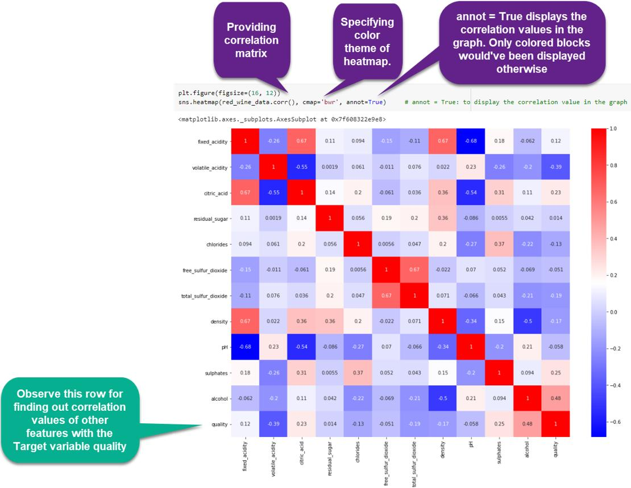
EDA helps in understanding the dataset.
- Feature relationships analysed
- Correlation heatmaps used
- Data patterns identified

Feature Selection
All parameters were considered important as they directly affect water quality.

Model Selection
Model selection is one of the most important steps in the machine learning process, as it directly influences the accuracy, efficiency, and reliability of the prediction system. Different machine learning algorithms have different strengths and weaknesses, and their performance depends on the nature of the dataset and the problem being solved. Therefore, in this project, multiple machine learning models were selected and implemented to identify the most suitable algorithm for predicting water potability.
The selection of models was based on their ability to handle classification problems, as the objective of the project is to classify water as potable (safe) or non-potable (unsafe). The dataset used in this project contains multiple features representing water quality parameters, making it necessary to use algorithms that can effectively handle multi-dimensional data and identify complex patterns.
The following machine learning models were selected for implementation and comparison:

🔹 Decision Tree
Decision Tree is a supervised machine learning algorithm that is widely used for classification and regression tasks. It works by splitting the dataset into smaller subsets based on feature values, forming a tree-like structure. Each node in the tree represents a decision based on a specific attribute, and the final output is obtained at the leaf nodes.
The main advantage of the Decision Tree algorithm is its simplicity and interpretability. It is easy to understand and visualize, making it useful for analyzing how decisions are made based on different parameters. In this project, Decision Tree was used to identify important features influencing water quality and to create a baseline model for comparison.
However, Decision Trees are prone to overfitting, especially when the tree becomes too complex. Therefore, its performance may vary depending on the dataset and parameter tuning.

🔹 Random Forest
Random Forest is an advanced ensemble learning algorithm that improves upon the limitations of Decision Trees. It works by creating multiple decision trees and combining their outputs to produce a final prediction. This approach reduces the risk of overfitting and increases the overall accuracy of the model.
In this project, Random Forest was used due to its ability to handle large datasets and provide stable predictions. It randomly selects subsets of data and features, ensuring diversity among the trees. The final output is determined based on majority voting, which enhances reliability.
Random Forest is particularly effective in handling noisy data and identifying important features. It also provides better generalization compared to a single Decision Tree, making it a strong candidate for water quality prediction.

🔹 K-Nearest Neighbors (KNN)
K-Nearest Neighbors (KNN) is a simple and effective classification algorithm that works based on similarity measures. It classifies a data point by analyzing the “k” nearest neighbors in the feature space and assigning the most common class among them.
In this project, KNN was used to explore how similarity-based classification performs on water quality data. It does not require any training phase, as it stores the entire dataset and makes predictions during runtime. This makes it easy to implement but computationally expensive for large datasets.
The performance of KNN depends on the choice of the value of “k” and the distance metric used. Although it is simple, it can produce good results when the dataset is well-structured and properly preprocessed.

🔹 Support Vector Machine (SVM)
Support Vector Machine (SVM) is a powerful and widely used machine learning algorithm for classification tasks. It works by finding the optimal hyperplane that separates data points into different classes with maximum margin. SVM is particularly effective in handling high-dimensional data and complex relationships between features.
In this project, SVM was used due to its high accuracy and strong generalization capability. It is capable of handling both linear and non-linear data by using kernel functions. The results showed that SVM performed better compared to other models, achieving higher accuracy in predicting water potability.
The main advantage of SVM is its ability to create a clear boundary between classes, even when the data is not perfectly separable. This makes it highly suitable for classification problems like water quality prediction.

🔹 Model Comparison and Selection
After implementing all the selected models, their performance was evaluated using appropriate evaluation metrics such as accuracy score. The results of different models were compared to determine which algorithm provides the best prediction accuracy and reliability.
Among all the models, Support Vector Machine (SVM) showed the best performance in terms of accuracy and consistency. Therefore, it was selected as the final model for the system. The comparison of multiple models helped in understanding their strengths and limitations and ensured that the best possible solution was chosen.

🔹 Conclusion
In conclusion, model selection is a critical step that determines the success of the machine learning system. By implementing and comparing multiple algorithms such as Decision Tree, Random Forest, KNN, and SVM, the project ensures a comprehensive analysis of different approaches. The selection of SVM as the final model highlights the importance of choosing the right algorithm for achieving accurate and reliable predictions in real-world applications.

Model Training
Model training is a fundamental phase in the machine learning process, where the selected algorithms learn patterns and relationships from the given dataset. The quality of training directly affects the accuracy and performance of the final prediction model. In this project, model training was performed carefully to ensure that the machine learning models can accurately predict water potability based on the input parameters.
The first step in model training was to divide the dataset into two parts: training data and testing data. This process is known as dataset splitting. Typically, a major portion of the data (such as 70%–80%) is used for training the model, while the remaining portion (20%–30%) is reserved for testing. This separation is important because it allows the model to be evaluated on unseen data, ensuring that it can generalize well and is not simply memorizing the training data.
After splitting the dataset, the training data was used to train multiple machine learning models, including Decision Tree, Random Forest, K-Nearest Neighbors (KNN), and Support Vector Machine (SVM). During the training process, each model learns the relationship between the input features (such as pH, hardness, solids, etc.) and the target variable (potability). The models adjust their internal parameters to minimize errors and improve prediction accuracy.
Proper training ensures that the model captures the underlying patterns in the dataset effectively. Care was taken to provide clean and preprocessed data to the models so that the learning process is efficient and free from noise or inconsistencies. Training also involved selecting appropriate parameters and configurations for each algorithm to achieve better performance.
Furthermore, training multiple models allows for a comparative analysis, helping in identifying which algorithm performs best for the given dataset. Each model has its own way of learning, and comparing them provides better insights into their strengths and weaknesses.
In conclusion, model training is a crucial step that enables machine learning algorithms to learn from data and make accurate predictions. By splitting the dataset and training multiple models using the training data, this project ensures that the system is capable of delivering reliable and efficient results in predicting water potability.

Model Evaluation
Model evaluation is an essential step in the machine learning process, as it helps in determining how well the trained models perform on unseen data. The purpose of evaluation is to measure the accuracy, reliability, and effectiveness of each model in predicting the correct output. In this project, model evaluation was carried out after training multiple machine learning algorithms to identify the best-performing model for water potability prediction.
To evaluate the models, the dataset was divided into training and testing sets. While the models were trained using the training data, their performance was assessed using the testing data. This ensures that the evaluation results are unbiased and reflect the model’s ability to generalize to new data. A model that performs well on training data but poorly on testing data is considered overfitted and not suitable for real-world applications.
The primary evaluation metric used in this project was accuracy. Accuracy measures the proportion of correctly predicted instances out of the total number of instances. It is calculated by comparing the predicted values with the actual values in the testing dataset. Accuracy is a simple and widely used metric for classification problems, especially when the dataset is balanced.
After calculating the accuracy for each model, a comparison was performed among all the selected algorithms, including Decision Tree, Random Forest, K-Nearest Neighbors (KNN), and Support Vector Machine (SVM). This comparison helped in identifying which model provides the most accurate and consistent predictions for the given dataset.
The evaluation results showed that different models performed differently based on their learning mechanisms. Among all the models, Support Vector Machine (SVM) achieved the highest accuracy, making it the most suitable choice for this project. This indicates that SVM was able to effectively capture the relationship between water quality parameters and potability.
In addition to accuracy, the comparison of models also provided insights into their strengths and limitations. Some models may perform faster but with lower accuracy, while others may take more time but provide better results. Therefore, evaluation plays a critical role in selecting the best model based on performance and efficiency.
In conclusion, model evaluation ensures that the developed system is reliable and capable of making accurate predictions. By using accuracy as the evaluation metric and comparing multiple models, this project successfully identifies the most effective algorithm for water potability prediction, thereby improving the overall performance of the system.

Result Generation
- Result generation is the final step in the machine learning pipeline, where the trained and evaluated model produces the output based on the input data. This step is crucial as it represents the actual application of the developed system and demonstrates how effectively the model can be used in real-world scenarios for predicting water potability.
- In this project, after selecting the best-performing model (Support Vector Machine), the system is used to generate predictions based on the input water quality parameters. The user provides values such as pH, hardness, solids, chloramines, sulfate, conductivity, organic carbon, trihalomethanes, and turbidity. These input values are first processed and formatted in the same way as the training data to ensure consistency and accuracy in predictions.
- The model then analyses these input parameters and produces an output in binary form. The result is generated as either 0 or 1, where:
- 0 indicates Non-Potable Water (Unsafe for drinking)
- 1 indicates Potable Water (Safe for drinking)
- This binary classification simplifies the interpretation of results and makes it easy for users to understand whether the given water sample is suitable for consumption or not.
- Once the prediction is generated, the final result is displayed to the user through the system interface. The output is presented in a clear and user-friendly manner, allowing even non-technical users to interpret the results without difficulty. This makes the system practical and accessible for real-world use.
- The result generation process is designed to be fast and efficient, providing instant predictions compared to traditional laboratory testing methods, which may take hours or days. This rapid response capability makes the system highly useful in situations where quick decision-making is required.
- Furthermore, the accuracy of the generated results depends on the quality of the trained model and the input data provided. Since the model has been evaluated and optimized during earlier stages, it ensures that the predictions are reliable and consistent.
- In conclusion, result generation is the final and most important stage where the system delivers its intended functionality. By providing quick, accurate, and easy-to-understand outputs, the developed model successfully demonstrates the practical application of machine learning in predicting water potability and supporting better decision-making.

HARDWARE & SOFTWARE
🔹 Hardware
- 16GB RAM
- AMD RYZEN 7 4565hrx
- GPU Nvidia RTXX 4050 6GB
🔹 Software
- Python
- Google Collab
- Power BI
- Ms Power Point 2024 Edition
Libraries:
- Pandas
- NumPy
- Matplotlib
- Seaborn
- Scikit-learn

TESTING TECHNOLOGIES
The developed system was tested using standard machine learning evaluation techniques to ensure the accuracy, reliability, and robustness of the prediction model. Testing plays a crucial role in validating the performance of the system and determining how effectively it can classify water as potable or non-potable based on the given input parameters.
One of the primary techniques used in this project is the Train-Test Split method. In this approach, the dataset is divided into two parts: a training set and a testing set. The training set is used to train the machine learning models, allowing them to learn patterns and relationships from the data. The testing set, on the other hand, is used to evaluate the performance of the trained models on unseen data. This helps in understanding how well the model generalizes and performs in real-world scenarios.
Another important evaluation metric used in this project is the Accuracy Score. Accuracy measures the proportion of correctly predicted instances out of the total number of predictions made by the model. It provides a simple and effective way to assess the performance of classification models. A higher accuracy value indicates better model performance and reliability in predicting water potability.
In addition to this, Model Comparison was performed to determine the best-performing algorithm. Multiple machine learning models, including Decision Tree, Random Forest, K-Nearest Neighbors (KNN), and Support Vector Machine (SVM), were implemented and evaluated. Each model was trained and tested using the same dataset, and their accuracy scores were compared. This comparative analysis helps in selecting the most suitable model for the problem.
The results showed that different models performed differently based on the dataset characteristics. However, the Support Vector Machine (SVM) model achieved the highest accuracy among all the models tested, making it the most effective algorithm for this project.
Overall, the use of these testing technologies ensures that the system is reliable and capable of providing accurate predictions. Proper evaluation and comparison of models enhance the credibility of the system and confirm its applicability in real-world water quality assessment scenarios.
Furthermore, the system was evaluated under different practical scenarios to ensure its robustness and adaptability. These scenarios included variations in input data values, missing parameter conditions, and testing with unseen data samples. The model was also checked for consistency by providing multiple inputs with similar characteristics to verify stable outputs. In cases where some parameters were slightly altered, the system still maintained reliable predictions, which shows its ability to handle real-world variations. Additionally, edge cases were considered where extreme values of parameters were given to analyse the behavior of the model. The results indicated that the system performs effectively even when the input data slightly deviates from the normal range. This scenario-based testing helps in understanding the limitations and strengths of the model. It also ensures that the system is not overfitted and can generalize well on new data. Overall, testing under multiple scenarios increases confidence in the system’s performance. Such evaluation makes the system more dependable for real-world applications and practical deployment.
CONTRIBUTION OF PROJECT
This project makes a significant contribution by demonstrating the practical application of machine learning techniques in solving real-world environmental problems, specifically in the domain of water quality assessment. The developed system provides a reliable and efficient method for predicting whether water is safe for human consumption based on various physicochemical parameters.
One of the key contributions of this project is the ability to provide fast and automated prediction of water quality. Unlike traditional laboratory-based testing methods, which require time, resources, and expert supervision, the proposed system delivers quick results using data-driven approaches. This enables faster decision-making and reduces delays in identifying unsafe water sources.
Another important contribution is the reduction in dependency on manual testing procedures. Conventional water testing involves physical sampling and chemical analysis, which can be costly and inaccessible in many regions. By utilizing machine learning algorithms, this project minimizes the need for such manual processes and offers a more scalable and cost-effective solution.
The project also highlights the effective application of machine learning in real-world scenarios. By implementing algorithms such as Decision Tree, Random Forest, K-Nearest Neighbors (KNN), and Support Vector Machine (SVM), the system showcases how data analysis and predictive modeling can be used to address environmental challenges. The comparative analysis of different models further strengthens the reliability of the system.
Additionally, the system provides valuable support for decision-making. Government agencies, environmental organizations, and water management authorities can use this model to assess water quality and take necessary actions. The predictions generated by the system can help in identifying contaminated water sources and implementing corrective measures in a timely manner.
Moreover, this project contributes to the broader goal of improving water quality management systems. By offering a technological solution, it promotes the use of intelligent systems in environmental monitoring. The approach can be further extended and integrated with real-time data collection systems, making it more effective and practical for large-scale deployment.
In conclusion, the project not only provides a technical solution for water potability prediction but also emphasizes the importance of adopting modern technologies like machine learning in environmental protection and public health management.

CONCLUSION
The project successfully demonstrates the effective application of machine learning techniques in predicting water potability based on various physicochemical parameters. Water quality assessment is a critical task that directly impacts human health, environmental sustainability, and economic development. In this project, a data-driven approach has been adopted to analyse and predict whether water is safe for human consumption. The developed system utilizes multiple water quality attributes such as pH, hardness, solids, chloramines, sulfate, conductivity, organic carbon, trihalomethanes, and turbidity to generate accurate predictions.
The implementation of machine learning in this domain provides a modern and efficient alternative to traditional water testing methods. Conventional laboratory-based testing, although accurate, is often time-consuming, expensive, and requires skilled professionals and specialized equipment. These limitations make it difficult to conduct continuous and large-scale monitoring of water quality, especially in rural or remote areas. By automating the prediction process using machine learning, the system significantly reduces the dependency on such traditional methods and provides faster and more accessible results.
A major strength of this project lies in the use of multiple machine learning algorithms to analyse and compare their performance. Models such as Decision Tree, Random Forest, K-Nearest Neighbors (KNN), and Support Vector Machine (SVM) were implemented and evaluated using appropriate performance metrics. This comparative approach ensures that the most suitable model is selected based on its accuracy and efficiency. Among all the models used, Support Vector Machine (SVM) demonstrated the highest accuracy and overall performance. This highlights the capability of SVM to handle complex datasets with multiple features and establish clear decision boundaries for classification tasks.
The results obtained from the project clearly indicate that machine learning can be effectively used to solve real-world environmental problems. The system is capable of analyzing complex relationships between different water quality parameters and generating reliable predictions. This not only enhances the efficiency of water quality assessment but also reduces human effort and operational costs. The ability of the model to learn from historical data and generalize to new inputs makes it a powerful tool for large-scale applications.
Another important aspect of this project is its contribution to decision-making processes. The system provides quick and accurate predictions, which can be extremely useful for various stakeholders such as government authorities, environmental agencies, industries, and public health organizations. These entities can use the system to monitor water quality, identify potential risks, and take preventive measures in a timely manner. For example, industries can ensure that the water used in their processes meets quality standards, while government bodies can use the system to improve public health initiatives and water management strategies.
In addition to its practical applications, the project also demonstrates the importance of proper data handling and preprocessing in machine learning. The accuracy of the model depends not only on the algorithm used but also on the quality of the data. Steps such as handling missing values, cleaning the dataset, and proper formatting play a crucial role in improving model performance. This project emphasizes the significance of these preprocessing techniques in building an effective prediction system.
Furthermore, the project highlights the scalability and adaptability of machine learning solutions. The developed model can be extended and integrated with advanced technologies such as Internet of Things (IoT) devices for real-time data collection. This would enable continuous monitoring of water quality and provide instant alerts in case of contamination. The integration of such technologies can further enhance the efficiency and usefulness of the system, making it suitable for real-world deployment.
From an academic and technical perspective, this project provides valuable insights into the application of machine learning in environmental science. It involves various stages such as data collection, preprocessing, model selection, training, evaluation, and result generation. Each of these stages contributes to the overall success of the system and helps in understanding the complete lifecycle of a machine learning project. This makes the project not only practically useful but also educationally significant.
Moreover, the project contributes to the broader goal of sustainable development. Access to clean and safe drinking water is one of the key objectives of global sustainability initiatives. By providing an efficient and cost-effective solution for water quality prediction, this project supports efforts to improve water management and reduce health risks associated with contaminated water. It also promotes the use of technology in addressing environmental challenges, which is essential for achieving long-term sustainability.
In conclusion, the project successfully validates the effectiveness of machine learning techniques in predicting water potability. It demonstrates how data-driven approaches can be used to develop efficient, reliable, and scalable solutions for real-world problems. The selection of Support Vector Machine (SVM) as the best-performing model further strengthens the system’s accuracy and reliability.
The project not only achieves its primary objective of building a prediction system but also opens new opportunities for future enhancements. With further improvements, such as the inclusion of real-time data, advanced algorithms, and user-friendly applications, the system can be transformed into a powerful tool for water quality monitoring and management. Ultimately, this project contributes to ensuring access to safe drinking water and improving public health, while also showcasing the potential of machine learning in solving critical environmental issues.

FUTURE ENHANCEMENT
The proposed system provides an effective solution for predicting water potability using machine learning techniques; however, there are several areas where the project can be further improved and enhanced in the future. These enhancements can increase the accuracy, usability, and real-world applicability of the system.
One of the major improvements can be the integration of real-time data. Currently, the system works on a static dataset, but in real-world scenarios, water quality parameters change continuously. By integrating real-time data collection mechanisms, the system can provide live predictions and more accurate results. This can be achieved by connecting the system with sensors or external data sources.
Another important enhancement is the use of IoT-based monitoring systems. Internet of Things (IoT) devices can be deployed to collect water quality parameters directly from sources such as rivers, lakes, or water supply systems. These sensors can continuously monitor parameters like pH, turbidity, and conductivity, and send the data to the machine learning model for instant prediction. This would make the system highly efficient and suitable for large-scale deployment.
The development of a mobile or web-based application can also improve the usability of the system. A user-friendly interface would allow users, industries, and government authorities to easily input data and view predictions. This would make the system more accessible and practical for everyday use.
Furthermore, the project can be enhanced by implementing advanced machine learning and deep learning models. Techniques such as Artificial Neural Networks (ANN), Gradient Boosting, or Ensemble Learning methods can be used to improve prediction accuracy and handle more complex datasets. Hyperparameter tuning and optimization techniques can also be applied to achieve better performance.
In addition, the system can be expanded to include data visualization dashboards that display trends and patterns in water quality over time. This would help in better analysis and decision-making.
In conclusion, with these future enhancements, the system can evolve into a robust, real-time, and scalable solution for monitoring and predicting water quality, thereby contributing significantly to environmental protection and public health management.
MAIN REPORT
CHAPTER 1: OBJECTIVE AND SCOPE

🔹 1.1 Objective
The primary objective of this project is to design and develop an intelligent and efficient Machine Learning-based system that can accurately predict whether water is potable (safe for drinking) or non-potable (unsafe for consumption). Water is one of the most essential natural resources required for the survival of all living organisms, and its quality directly affects human health, economic activities, and environmental sustainability. Ensuring access to safe drinking water is a major global challenge, and this project aims to address this issue by utilizing modern computational techniques.
The system developed in this project uses a data-driven approach to analyse various physicochemical parameters of water. These parameters include pH, hardness, total dissolved solids, chloramines, sulfate concentration, conductivity, organic carbon, trihalomethanes, and turbidity. Each of these attributes plays a significant role in determining the quality of water and its suitability for human consumption. By analyzing these parameters collectively, the system can make informed predictions about water potability.
One of the key objectives of this project is to automate the process of water quality assessment. Traditionally, water quality testing is performed using laboratory-based methods that involve chemical analysis and expert evaluation. While these methods are accurate, they are often time-consuming, expensive, and require specialized equipment and trained personnel. This makes them less accessible, especially in rural and underdeveloped regions where such facilities are limited. The proposed system addresses these challenges by providing a faster, cost-effective, and automated solution using machine learning.
Another important objective of this project is to explore and implement different machine learning algorithms for classification tasks. Algorithms such as Decision Tree, Random Forest, K-Nearest Neighbors (KNN), and Support Vector Machine (SVM) are applied to the dataset to evaluate their performance in predicting water potability. Each algorithm has its own advantages and limitations, and comparing their performance helps in identifying the most suitable model for the given problem. The project emphasizes the importance of selecting the right model to achieve high accuracy and reliability.
The project also focuses on improving the overall efficiency of water quality monitoring systems. By reducing the time required for analysis and eliminating the need for manual intervention, the system enables quicker decision-making. This is particularly useful in situations where immediate action is required to prevent the consumption of contaminated water. The ability to generate instant predictions makes the system highly practical and valuable for real-world applications.
In addition to prediction, the project aims to provide insights into the impact of different water quality parameters on potability. By analyzing the dataset and understanding the relationship between input features and the target variable, the system helps in identifying key factors that influence water quality. This knowledge can be useful for researchers, policymakers, and environmental agencies in developing strategies for water quality management.
Another objective of this project is to demonstrate the practical application of machine learning in solving real-world problems. Machine learning is a rapidly growing field with applications in various domains such as healthcare, finance, transportation, and environmental science. This project showcases how machine learning techniques can be effectively used to address environmental challenges and improve public health.
The system is also designed with usability in mind. It aims to provide a user-friendly interface where users can input water quality parameters and receive instant predictions. This makes the system accessible to a wide range of users, including professionals, researchers, and general individuals. By simplifying the process of water quality assessment, the system encourages more people to take an active role in ensuring water safety.
Furthermore, the project aims to contribute to sustainable development by promoting the use of technology in environmental monitoring. Access to clean and safe drinking water is one of the key goals of global sustainability initiatives. By providing an efficient and scalable solution for water quality prediction, this project supports efforts to improve water management and reduce health risks associated with contaminated water.
In conclusion, the objective of this project is not only to develop a predictive model but also to create a comprehensive system that enhances the process of water quality assessment. By integrating machine learning techniques with environmental data, the project provides a reliable, efficient, and scalable solution for predicting water potability. It highlights the potential of technology in addressing critical global issues and contributes to the advancement of knowledge in the field of machine learning and environmental science.

🔹 1.2 Scope
The scope of this project is focused on the development, implementation, and evaluation of a machine learning-based system for predicting water potability using historical data. The system is designed to analyse multiple water quality parameters and generate predictions based on trained models. It provides a structured and systematic approach to water quality assessment, making it suitable for both academic and practical applications.
The project primarily deals with structured datasets that contain various physicochemical attributes of water samples. These datasets are used to train machine learning models, which learn patterns and relationships between input features and the target variable. The system processes the data through several stages, including data collection, preprocessing, model training, evaluation, and prediction. Each stage plays a crucial role in ensuring the accuracy and reliability of the final output.
One of the key aspects of the project’s scope is its applicability in different domains. The system can be used by environmental researchers to study water quality trends and analyse the impact of different factors on water safety. Government and regulatory agencies can utilize the system to monitor water quality and ensure compliance with safety standards. Industries that rely on water for production processes can use the system to maintain quality control and prevent operational issues. Additionally, the system can be useful for individuals who want a quick and convenient way to assess the safety of water in their local areas.
The project also demonstrates the potential of machine learning in handling complex and multi-dimensional data. Water quality is influenced by multiple parameters, and analyzing these parameters manually can be challenging. Machine learning models are capable of processing large datasets and identifying patterns that may not be easily visible through traditional methods. This makes the system highly efficient and effective in predicting water potability.
Despite its advantages, the project has certain limitations that need to be acknowledged. One of the primary limitations is its dependency on the quality and completeness of the dataset used for training. If the dataset contains errors, missing values, or is not representative of real-world conditions, it may affect the accuracy of the predictions. Therefore, proper data preprocessing and validation are essential to ensure reliable results.
Another limitation is that the system does not account for all possible environmental factors that may influence water quality. Factors such as geographical variations, seasonal changes, and unexpected contamination sources are not included in the dataset. As a result, the predictions may not fully reflect real-world conditions in all scenarios.
Furthermore, the system currently does not support real-time data collection or live monitoring. It relies on static historical data, which limits its ability to provide real-time insights. This can be a significant limitation in situations where immediate detection of contamination is required. However, this limitation also presents an opportunity for future enhancement.
The scope of the project can be significantly expanded by integrating advanced technologies. One of the major areas of improvement is the use of Internet of Things (IoT) devices and sensors for real-time data collection. These sensors can continuously monitor water quality parameters and provide real-time data to the system. By combining IoT with machine learning, it is possible to develop a fully automated and real-time water quality monitoring system.
Another potential enhancement is the development of a mobile or web-based application that allows users to access the system easily. This would improve the usability and accessibility of the system, making it more practical for real-world deployment. Users can input data through the application and receive instant predictions, making the system more interactive and user-friendly.
The project can also be extended by implementing advanced machine learning and deep learning techniques. Algorithms such as Neural Networks, Gradient Boosting, and Ensemble Learning methods can be used to improve prediction accuracy and handle more complex datasets. Additionally, expanding the dataset to include more diverse and real-world data can enhance the robustness and reliability of the system.
From an academic perspective, the project provides a comprehensive understanding of the machine learning lifecycle, including data collection, preprocessing, model selection, training, evaluation, and deployment. It serves as a valuable learning experience for students and researchers interested in data science and environmental applications.
In conclusion, the scope of this project extends beyond basic prediction and provides a foundation for developing advanced water quality monitoring systems. It highlights the potential of machine learning in addressing environmental challenges and opens up opportunities for further research and innovation. The project not only demonstrates the practical application of machine learning but also contributes to improving water quality management and public health.

CHAPTER 2: THEORETICAL BACKGROUND

🔹 2.1 Introduction to Water Quality
Water quality is one of the most significant factors that influence human health, economic development, and environmental sustainability. Water is an essential natural resource that supports life on Earth, and its quality determines its suitability for various purposes such as drinking, agriculture, industrial use, and ecosystem maintenance. The availability of clean and safe drinking water is a fundamental human right; however, ensuring water safety remains a major global challenge.
Water quality refers to the physical, chemical, and biological characteristics of water. These characteristics determine whether water is suitable for consumption or other uses. High-quality water should be free from harmful contaminants, have balanced chemical properties, and meet the standards defined by health organizations.
In many parts of the world, water resources are increasingly being contaminated due to rapid industrialization, urbanization, and population growth. Industrial waste, agricultural runoff, sewage discharge, and improper waste disposal contribute to water pollution. These pollutants introduce harmful substances such as heavy metals, toxic chemicals, and microorganisms into water sources, making them unsafe for human consumption.
Maintaining water quality is therefore essential not only for human health but also for environmental protection. Contaminated water affects aquatic ecosystems, disrupts food chains, and leads to biodiversity loss. As a result, continuous monitoring and assessment of water quality have become necessary to ensure safe water supply and sustainable resource management.

🔹 2.2 Importance of Water Quality Monitoring
Water quality monitoring is the process of analyzing water characteristics to ensure that it meets safety standards. It plays a crucial role in identifying contamination, preventing health hazards, and maintaining ecological balance.
One of the primary reasons for monitoring water quality is to protect human health. Contaminated water is a major cause of waterborne diseases such as cholera, typhoid, dysentery, and diarrhea.
These diseases can spread rapidly and lead to severe health complications, especially in regions with limited access to healthcare facilities. Regular monitoring helps in early detection of contamination and prevents the consumption of unsafe water.
Water quality monitoring is also important for economic development. Industries rely heavily on water for production processes, and poor water quality can affect product quality, damage equipment, and increase operational costs. Similarly, agriculture depends on water for irrigation, and contaminated water can negatively impact crop yield and soil health.
Environmental sustainability is another key aspect of water quality monitoring. Healthy water ecosystems support aquatic life and maintain biodiversity. Monitoring helps in identifying pollution sources and implementing corrective measures to protect natural water bodies.
Traditional water quality monitoring methods involve laboratory-based testing, which can be time-consuming and expensive. These methods require sample collection, chemical analysis, and expert interpretation. While they provide accurate results, they are not suitable for real-time monitoring or large-scale applications.
This limitation has led to the adoption of advanced technologies such as machine learning, which can provide faster and more efficient solutions for water quality assessment.

🔹 2.3 Introduction to Machine Learning
Machine Learning (ML) is a subset of Artificial Intelligence (AI) that enables systems to learn from data and make predictions or decisions without being explicitly programmed.
It involves the use of algorithms that can identify patterns in data and improve their performance over time.
Machine learning has gained significant importance in recent years due to its ability to handle large datasets and solve complex problems. It is widely used in various domains such as healthcare, finance, transportation, and environmental science.
In the context of this project, machine learning is used to predict water potability based on historical data. The system learns from existing water quality data and uses this knowledge to classify new water samples as potable or non-potable.
Machine learning models work by analyzing input features (water quality parameters) and mapping them to an output (potability status).
The accuracy of the model depends on the quality of data and the choice of algorithm.

🔹 2.4 Types of Machine Learning
Machine learning can be broadly classified into three main types:
1. Supervised Learning
Supervised learning involves training a model using labeled data, where both input and output are known. The model learns the relationship between input features and the target variable.
In this project, supervised learning is used to classify water samples into:
- Potable (1): Safe for human consumption
- Non-potable (0): Unsafe for drinking
2. Unsupervised Learning
Unsupervised learning deals with unlabeled data and aims to identify hidden patterns or structures within the data. It is commonly used for clustering and association tasks.
3. Reinforcement Learning
Reinforcement learning involves training an agent to make decisions by rewarding desired actions and penalizing undesired ones. It is mainly used in robotics and gaming.
Among these, supervised learning is most relevant for this project as it deals with classification problems.

🔹 2.5 Classification in Machine Learning
Classification is a type of supervised learning where the model predicts categorical outcomes. In this project, classification is used to determine whether water is potable or non-potable.
The classification process involves:
- Training the model using labeled data
- Learning patterns from input features
- Predicting the class of new data
Several classification algorithms can be used, such as Decision Tree, Random Forest, K-Nearest Neighbors (KNN), and Support Vector Machine (SVM).

🔹 2.6 Dataset Description
The dataset used in this project contains multiple water quality parameters that influence potability. It is stored in CSV format and consists of numerical values representing different attributes.
Each row in the dataset represents a water sample, and each column represents a specific parameter. The target variable indicates whether the water is potable (1) or non-potable (0).
The dataset serves as the foundation for training machine learning models. Proper preprocessing and analysis of this data are essential for achieving accurate predictions.

🔹 2.7 Water Quality Parameters
The dataset includes several important parameters that determine water quality. These parameters are explained below:
🔸 pH (Potential of Hydrogen)
pH measures the acidity or alkalinity of water on a scale of 0 to 14. A pH value of 7 is considered neutral, values below 7 indicate acidity, and values above 7 indicate alkalinity. Drinking water typically has a pH between 6.5 and 8.5.
🔸 Hardness
Hardness refers to the concentration of dissolved minerals such as calcium and magnesium in water. High hardness can cause scaling in pipes and affect the taste of water.
🔸 Total Dissolved Solids (TDS)
TDS represents the total concentration of dissolved substances in water, including minerals, salts, and organic matter. High TDS levels can affect water taste and safety.
🔸 Chloramines
Chloramines are disinfectants used in water treatment to kill harmful microorganisms. While they help in maintaining water safety, excessive levels can be harmful.
🔸 Sulfate
Sulfate is a naturally occurring substance found in water. High sulfate levels can affect taste and may cause health issues such as diarrhea.
🔸 Conductivity
Conductivity measures water’s ability to conduct electricity, which depends on the presence of dissolved ions. It is an indicator of water purity.
🔸 Organic Carbon
Organic carbon indicates the presence of organic matter in water. High levels may suggest contamination from biological sources.
🔸 Trihalomethanes (THMs)
THMs are chemical compounds formed during water disinfection. High levels of THMs can pose health risks over long-term exposure.
🔸 Turbidity
Turbidity measures the clarity of water. High turbidity indicates the presence of suspended particles, which may contain harmful microorganisms.

🔹 2.8 Role of Parameters in Water Potability
Each parameter contributes to determining whether water is safe for drinking. While some parameters affect taste and appearance, others have direct health implications.
For example:
- Low or high pH levels can make water corrosive or harmful
- High TDS can indicate contamination
- Excessive turbidity may contain pathogens
Machine learning models analyse these parameters collectively rather than individually. This allows the system to identify complex relationships and patterns that influence water quality.

🔹 2.9 Application of Machine Learning in Water Quality Prediction
Machine learning provides an efficient and scalable solution for water quality prediction. It eliminates the need for manual analysis and reduces the time required for testing.
The key advantages of using machine learning include:
- Fast and automated predictions
- Ability to handle large datasets
- Improved accuracy with proper training
- Reduced human intervention
In this project, multiple machine learning algorithms are used to analyse water quality data and generate predictions. The models are trained using historical data and evaluated based on their performance.

🔹 2.10 Advantages of Machine Learning Approach
The use of machine learning in this project offers several benefits:
- Efficiency: Reduces time required for water quality analysis
- Cost-effectiveness: Minimizes reliance on laboratory testing
- Scalability: Can handle large datasets and multiple parameters
- Accuracy: Provides reliable predictions when properly trained

🔹 2.11 Limitations
Despite its advantages, the machine learning approach has certain limitations:
- Depends on the quality of the dataset
- May not capture all real-world environmental factors
- Requires proper preprocessing and tuning

🔹 2.12 Conclusion
In conclusion, water quality is a critical factor that affects health, environment, and economic development. Traditional methods of water quality assessment, while accurate, are not always efficient or scalable.
Machine learning offers a modern solution by enabling fast, automated, and data-driven predictions.
The theoretical concepts discussed in this chapter provide the foundation for the development of the water potability prediction system. By understanding the importance of water quality parameters and the role of machine learning, this project demonstrates how technology can be used to address real-world challenges effectively.

CHAPTER 3: SYSTEM ANALYSIS AND DESIGN

🔹 3.1 System Analysis
System analysis is a crucial phase in the development of any software system, as it involves understanding the problem, identifying system requirements, and defining the overall structure of the solution.
In the context of this project, the system analysis focuses on designing a Machine Learning-based solution that can efficiently analyse water quality parameters and predict water potability.
The need for such a system arises due to the limitations of traditional water quality testing methods, which are often time-consuming, expensive, and require expert intervention. The proposed system aims to overcome these challenges by providing a fast, automated, and reliable method for water quality prediction using data-driven techniques.
The system is designed to process water quality data in a structured manner and convert it into meaningful insights. It takes raw input data, performs necessary preprocessing, applies machine learning models, and generates predictions indicating whether the water is safe for drinking.

🔸 3.1.1 Existing System Analysis
The existing system for water quality assessment primarily relies on laboratory-based testing. These methods involve collecting water samples, performing chemical and biological tests, and analyzing the results manually.
While these methods are highly accurate, they have several limitations:
- They require significant time for testing and analysis
- High operational and maintenance costs
- Dependence on skilled professionals and laboratory infrastructure
- Limited accessibility in rural or remote areas
- Lack of real-time monitoring capabilities
Due to these limitations, it becomes difficult to monitor water quality continuously and respond quickly to contamination issues.

🔸 3.1.2 Proposed System Analysis
The proposed system introduces a Machine Learning-based approach to water quality prediction. It automates the process of analyzing water parameters and provides instant results. The system is capable of handling large datasets and identifying patterns that may not be easily detectable through manual analysis.
Key features of the proposed system include:
- Automated data processing and prediction
- Faster analysis compared to traditional methods
- Reduced dependency on manual testing
- Ability to handle multiple parameters simultaneously
- Scalable and adaptable for future enhancements
This system improves efficiency and enables quick decision-making, making it highly useful for real-world applications.

🔸 3.1.3 System Requirements
Functional Requirements:
- The system should accept water quality data as input
- It should preprocess the dataset by handling missing values
- It should train machine learning models using the dataset
- It should generate predictions based on trained models
- It should display results in an understandable format
Non-Functional Requirements:
- High accuracy and reliability
- Fast processing time
- User-friendly interface
- Scalability for handling large datasets
- Maintainability and flexibility

🔸 3.1.4 Input / Process / Output Analysis
🔹 Input:
The system takes input in the form of a dataset stored in CSV format. The dataset contains multiple water quality parameters such as:
- pH
- Hardness
- Total Dissolved Solids
- Chloramines
- Sulfate
- Conductivity
- Organic Carbon
- Trihalomethanes
- Turbidity
Each record represents a water sample with corresponding values.

🔹 Process:
The system follows a structured workflow:
- Data Collection – Importing dataset
- Data Preprocessing – Cleaning and handling missing values
- Feature Analysis – Understanding relationships between variables
- Model Training – Applying machine learning algorithms
- Prediction – Generating output based on trained model
🔹 Output:
The output is generated in binary form:
- 1 → Potable (Safe for drinking)
- 0 → Non-potable (Unsafe for drinking)
This output helps users quickly understand water quality.

🔹 3.2 System Design
System design is the process of defining the architecture, components, modules, and data flow of the system. The proposed system is designed using a Machine Learning pipeline approach to ensure smooth data processing and efficient prediction generation.

🔸 3.2.1 Overall System Architecture
The system architecture consists of multiple layers that work together to process data and generate predictions. These layers include:
- Data Input Layer
- Data Processing Layer
- Machine Learning Layer
- Output Layer
Each layer performs a specific function and ensures seamless data flow throughout the system.

🔸 3.2.2 System Flow
The system follows a sequential flow of operations:
Input Data → Data Preprocessing → Model Training → Prediction → Output
- Input Data: Raw dataset is provided
- Data Preprocessing: Data is cleaned and formatted
- Model Training: ML algorithms are trained
- Prediction: Model predicts potability
- Output: Result is displayed
This structured flow ensures accuracy and efficiency.
🔸 3.2.3 Flowchart Explanation
The flowchart of the system represents the step-by-step working process:
- Start
- Load Dataset
- Check for Missing Values
- Perform Data Cleaning
- Split Dataset into Training and Testing
- Train Machine Learning Models
- Evaluate Models
- Select Best Model
- Generate Prediction
- Display Output
- End
The flowchart helps in visualizing system operations clearly.

3.2.4 Data Flow Diagram (DFD)
🔹 Level 0 DFD (Context Diagram)
The Level 0 DFD represents the overall system as a single process:
- Input: Water Quality Data
- Process: ML-based Prediction System
- Output: Water Potability Result
It shows how data flows into the system and produces output.

🔹 Level 1 DFD
The Level 1 DFD provides a detailed view of internal processes:
- Data Input Module
- Data Preprocessing Module
- Model Training Module
- Prediction Module
- Output Module
Each module performs a specific function and passes data to the next stage.

🔸 3.2.5 Module Description
1. Data Input Module
Responsible for loading dataset from CSV file.
2. Data Preprocessing Module
Handles missing values, formatting, and cleaning of data.
3. Model Training Module
Applies machine learning algorithms to train models.
4. Prediction Module
Generates predictions based on trained model.
5. Output Module
Displays the final result to the user.

🔸 3.2.6 System Design Characteristics
The system is designed with the following features:
- Modularity: Each component works independently
- Scalability: Can handle large datasets
- Efficiency: Fast processing and prediction
- Flexibility: Easy to update or improve
- Reliability: Accurate and consistent results

🔸 3.2.7 Advantages of System Design
- Reduces manual effort
- Provides quick predictions
- Improves accuracy
- Easy to use and maintain
- Suitable for real-world applications

🔸 3.2.8 Limitations of Design
- Depends on dataset quality
- No real-time monitoring
- Requires preprocessing for accuracy

🔹 3.3 Conclusion
In conclusion, the system analysis and design phase plays a vital role in the successful development of the water potability prediction system.
The proposed system effectively addresses the limitations of traditional water testing methods by introducing an automated and data-driven approach.
By integrating machine learning techniques, the system ensures faster and more efficient analysis of water quality parameters. The structured workflow enables smooth transformation of raw data into meaningful predictions.
The modular design enhances the flexibility of the system, allowing easy updates and improvements in the future.
Each component of the system is clearly defined, ensuring better maintainability and scalability. The use of multiple machine learning models improves the reliability and accuracy of predictions.
The system also reduces human effort and minimizes the chances of manual errors. Through proper data preprocessing and model training, the system is capable of handling complex datasets effectively.
The design ensures that the output is simple and easy to understand for users. Although there are some limitations, such as dependency on dataset quality, the overall system performance remains strong.
The proposed architecture provides a solid foundation for future enhancements like real-time monitoring and IoT integration. This system demonstrates the practical application of machine learning in solving environmental problems.
It also highlights the importance of technological advancements in improving public health and safety. Overall, the system analysis and design successfully establish a reliable and efficient framework for water quality prediction.
CHAPTER 3: SYSTEM ANALYSIS AND DESIGN (Expanded Version)

3.1 System Analysis
System Analysis is one of the most crucial phases in the development of any software system. It involves a detailed study of the existing system, identification of problems, and the formulation of requirements for the proposed system.
In this project, the system is designed to analyse water quality data and predict its potability using Machine Learning techniques.
The primary objective of the system is to provide an automated and intelligent solution for determining whether water is safe for drinking. Traditional water testing methods are often time-consuming, expensive, and require laboratory analysis.
This system aims to overcome these limitations by using data-driven approaches.

3.1.1 Problem Identification
Water contamination is a major global issue affecting millions of people. Access to clean and safe drinking water is essential for human health.
However, manual testing of water quality is not always feasible in remote or underdeveloped areas.
The major problems identified are:
- Lack of real-time water quality assessment
- Dependence on manual and laboratory-based testing
- High cost and time consumption
- Inconsistent monitoring of water sources
The proposed system addresses these challenges by implementing a Machine Learning model that can predict water potability based on input parameters.

3.1.2 Proposed System Overview
The proposed system is a data-driven application that uses Machine Learning algorithms to analyse water quality parameters and predict whether the water is potable or not.
The system processes input data through multiple stages including preprocessing, analysis, training, and prediction.
It provides a binary output indicating water quality.

3.1.3 Input Specification
The input to the system is a dataset in CSV format containing multiple water quality parameters.
These parameters play a crucial role in determining the safety of water.
Some of the key attributes include:
- pH level
- Hardness
- Solids (Total Dissolved Solids)
- Chloramines
- Sulfate
- Conductivity
- Organic Carbon
- Trihalomethanes
- Turbidity
These attributes are collected from various water sources and stored in a structured format for processing.

3.1.4 Process Description
The system follows a structured pipeline for transforming raw data into meaningful predictions. The process includes the following stages:
1. Data Preprocessing
- Handling missing values
- Removing inconsistencies
- Normalization and scaling of data
- Data cleaning to improve quality
2. Feature Analysis and Selection
- Identifying important features affecting water quality
- Eliminating irrelevant or redundant attributes
- Improving model efficiency and accuracy
3. Model Training
- Applying Machine Learning algorithms such as:
  - Logistic Regression
  - Decision Tree
  - Random Forest
- Training the model using historical data
4. Prediction Generation
- Input data is passed to the trained model
- The system generates output based on learned patterns

3.1.5 Output Specification
The output of the system is a binary classification result:
- 1 → Potable Water (Safe for Drinking)
- 0 → Non-Potable Water (Unsafe for Drinking)
The output is displayed in a user-friendly format, making it easy to understand even for non-technical users.

3.1.6 Feasibility Analysis
The proposed system is feasible in multiple aspects:
Technical Feasibility
- Uses widely available tools like Python and ML libraries
- Easy to implement and maintain
Economic Feasibility
- Low cost compared to laboratory testing
- Reduces operational expenses
Operational Feasibility
- Easy to use interface
- Requires minimal user training

3.2 System Design
System Design defines the architecture, components, modules, and data flow of the system. The proposed system follows a Machine Learning pipeline architecture that ensures efficient and structured processing of data.
3.2.1 System Architecture
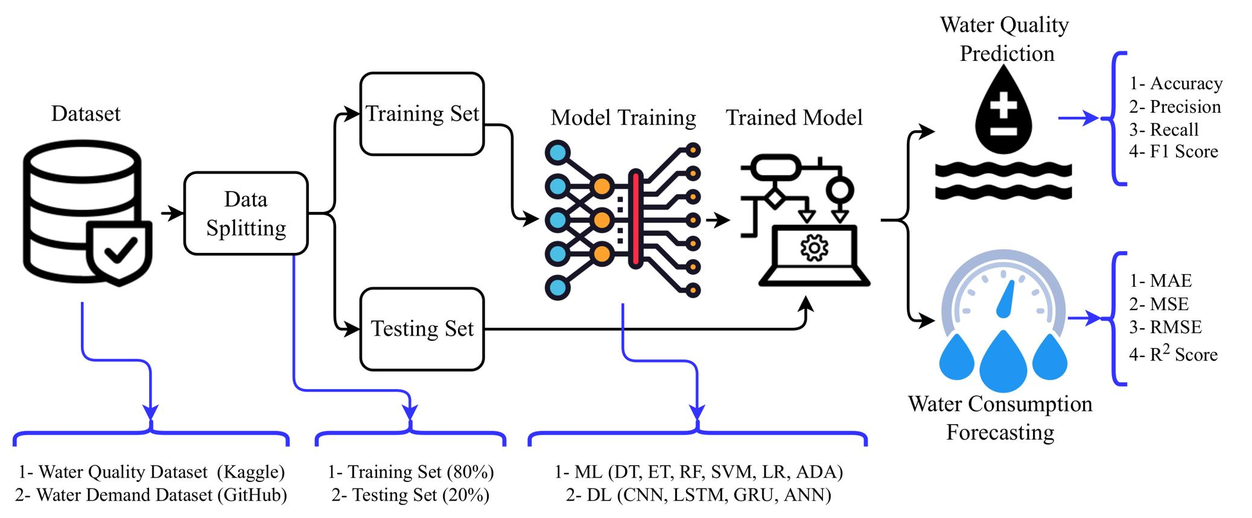
The system architecture is designed in a sequential pipeline format where each stage performs a specific function.
The flow of the system is as follows:
Input Data → Data Preprocessing → Model Training → Prediction → Output

3.2.2 Module Description
The system is divided into several modules, each responsible for a specific task:

1. Data Input Module
- Accepts CSV file containing water quality parameters
- Ensures proper data format and structure

2. Data Preprocessing Module
- Cleans the dataset
- Handles missing values
- Normalizes the data
This module ensures that the data is suitable for machine learning algorithms.

3. Model Training Module
- Selects appropriate ML algorithm
- Trains the model using training data
- Evaluates model performance

4. Prediction Module
- Takes new input data
- Uses trained model to generate predictions

5. Output Module
- Displays result in binary form (0 or 1)
- Can be extended to show probability or confidence score

3.2.3 Data Flow Design
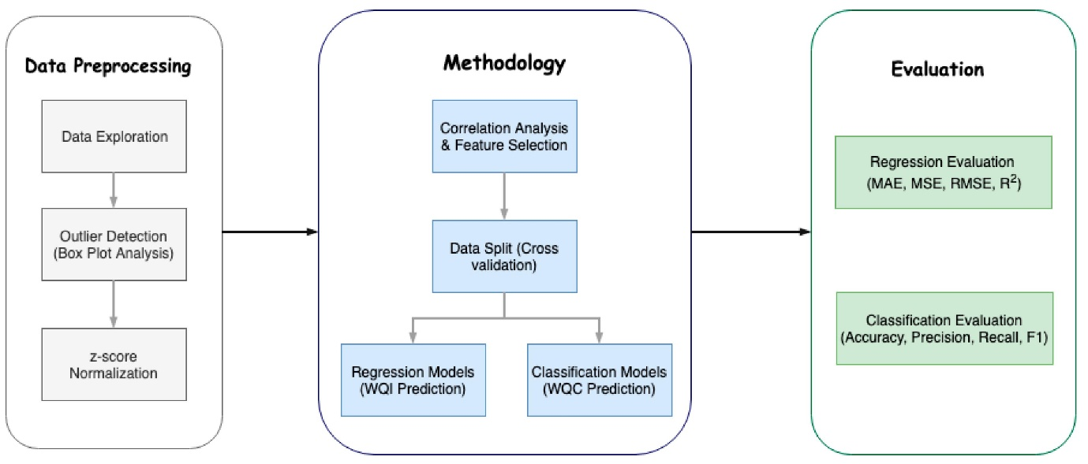
The Data Flow Diagram (DFD) represents how data moves through the system:
- User provides input dataset
- Data is processed and cleaned
- Model is trained using processed data
- Prediction is generated
- Result is displayed

3.2.4 Design Characteristics
The system is designed with the following characteristics:
- Modularity: Each component works independently
- Scalability: Can handle large datasets
- Flexibility: Easy to update or replace models
- Efficiency: Optimized for fast processing

3.2.5 Advantages of System Design
- Reduces human effort
- Provides quick and accurate results
- Cost-effective solution
- Easily deployable

3.2.6 Limitations
- Accuracy depends on dataset quality
- Requires initial training data
- May need regular updates for better performance

Conclusion of Chapter
The System Analysis and Design phase plays a vital role in establishing a clear and structured foundation for the development of the water potability prediction system. It systematically defines the overall architecture, operational workflow, and functional components required to build an efficient and reliable solution.
Through detailed analysis, the system identifies the key challenges associated with traditional water quality testing and proposes a modern, data-driven approach to overcome these limitations.
The design phase ensures that each module of the system, including data input, preprocessing, model training, and prediction, is logically organized and well-integrated. This structured workflow enables smooth data flow from raw input to final output, reducing complexity and improving system performance.
By adopting a modular design approach, the system becomes easier to maintain, upgrade, and scale in the future.
Furthermore, the integration of Machine Learning techniques significantly enhances the system’s capability to analyse complex patterns within water quality data. It allows the system to learn from historical datasets and make accurate predictions regarding water safety.
This not only reduces dependency on manual testing but also minimizes human error.
The use of automation ensures that results can be generated quickly and consistently, saving both time and resources.
The system is designed to handle large datasets efficiently, making it suitable for real-world applications where continuous monitoring is required. Additionally, its user-friendly output format makes it accessible even to non-technical users.
Overall, the System Analysis and Design phase ensures that the proposed solution is practical, efficient, and adaptable.
It highlights how the combination of structured design and Machine Learning technology can provide a cost-effective, accurate, and scalable solution for predicting water quality, thereby contributing to improved public health and environmental sustainability.

CHAPTER 4: SYSTEM PLANNING

The development of this project was carried out in a structured, systematic, and well-organized manner to ensure accuracy, efficiency, and reliability in predicting water potability. Proper planning is a crucial phase in any project, as it defines the workflow, identifies necessary resources, and ensures that each step is executed effectively.
In this project, a step-by-step approach was followed, covering all stages from data collection to final result generation. Each stage was carefully designed to contribute to the overall success of the system.

🔹 4.1 Data Collection
The first and most important step in the project was the collection of the dataset. The quality and reliability of the dataset play a significant role in determining the performance of machine learning models. For this project, a water quality dataset was collected in CSV (Comma Separated Values) format from reliable and publicly available sources.
The dataset includes multiple physicochemical parameters such as pH, hardness, total dissolved solids, chloramines, sulfate, conductivity, organic carbon, trihalomethanes, and turbidity.
These parameters are widely recognized as key indicators of water quality and are essential for determining whether water is safe for drinking.
Each row in the dataset represents a water sample, and each column corresponds to a specific parameter. The dataset also includes a target variable indicating whether the water is potable (1) or non-potable (0).
This labeled data is essential for supervised learning, as it allows the machine learning models to learn patterns and relationships between input features and output classes.
The dataset was carefully examined to ensure that it contains sufficient records and meaningful information for training and testing the models. A well-collected dataset forms the foundation of any successful machine learning project.

🔹 4.2 Data Cleaning
After collecting the dataset, the next step was data cleaning, which is a critical part of data preprocessing. Real-world datasets often contain missing values, inconsistencies, and noise that can negatively affect model performance. Therefore, it is necessary to clean and prepare the data before applying machine learning algorithms.
In this project, missing values were identified in various columns of the dataset. Instead of removing entire rows, which could lead to data loss, mean imputation was used to replace missing values. This method involves calculating the average value of a column and filling missing entries with that value. This approach helps in maintaining the integrity of the dataset while ensuring completeness.
Additionally, the dataset was checked for duplicate entries and inconsistent values. Proper formatting and standardization were applied to ensure that all data is in a uniform structure. Data cleaning improves the quality of the dataset and ensures that the models receive accurate and meaningful input.

🔹 4.3 Exploratory Data Analysis (EDA)
Exploratory Data Analysis (EDA) is an essential step in understanding the dataset and identifying patterns, trends, and relationships among variables. In this project, EDA was performed using various statistical and visualization techniques.
Graphs such as histograms, box plots, and correlation matrices were used to analyse the distribution of data and detect outliers. These visualizations help in understanding how each parameter behaves and how it influences water quality. For example, correlation analysis helps in identifying relationships between variables, such as how pH levels may relate to other chemical properties.
EDA also helps in identifying important features that have a strong impact on the target variable. By analyzing the data, it becomes easier to understand which parameters are more significant in determining water potability.
This step plays a crucial role in improving model performance, as it provides insights that guide feature selection and model building.

🔹 4.4 Model Selection
Model selection is a key step in the system planning process. Choosing the right machine learning algorithm is essential for achieving accurate and reliable predictions.
In this project, multiple classification algorithms were selected and tested to determine the best-performing model.
The models used in this project include:
- Decision Tree
- Random Forest
- K-Nearest Neighbors (KNN)
- Support Vector Machine (SVM)
Each of these algorithms has its own strengths and weaknesses.
For example, Decision Trees are easy to interpret, Random Forest provides higher accuracy through ensemble learning, KNN is simple and effective for smaller datasets, and SVM is powerful for handling complex classification problems.
By testing multiple models, the project ensures that the most suitable algorithm is selected based on performance metrics.
This comparative approach enhances the reliability of the system.

🔹 4.5 Model Training
Once the models were selected, the next step was model training. In this stage, the dataset was divided into two parts: training data and testing data. The training data is used to train the machine learning models, while the testing data is used to evaluate their performance.
The models learn patterns from the training data by analyzing the relationships between input features and the target variable.
During training, the algorithms adjust their internal parameters to minimize errors and improve prediction accuracy.
Proper training is essential to ensure that the models can generalize well to new and unseen data. Overfitting and underfitting are carefully avoided by using appropriate techniques and validation methods.

🔹 4.6 Model Evaluation
Model evaluation is performed to measure the performance of trained models and determine their effectiveness. In this project, accuracy was used as the primary evaluation metric. Accuracy represents the percentage of correct predictions made by the model.
In addition to accuracy, other evaluation techniques such as confusion matrix analysis can also be used to understand model performance in more detail.
The confusion matrix provides information about true positives, true negatives, false positives, and false negatives.
By comparing the performance of different models, the best-performing model is selected. In this project, Support Vector Machine (SVM) showed the highest accuracy, making it the most suitable model for predicting water potability.

🔹 4.7 Result Generation
The final stage of system planning is result generation. In this step, the selected model is used to generate predictions based on input data. The output is provided in a simple binary format:
- 1 → Potable (Safe for drinking)
- 0 → Non-potable (Unsafe for drinking)
The results are displayed in a user-friendly manner, making it easy for users to understand the outcome. This step completes the entire machine learning pipeline, from data collection to prediction.
Additionally, the results from different models are compared to highlight their performance differences. This comparison helps in validating the effectiveness of the selected model.

🔹 4.8 Importance of System Planning
Proper system planning ensures that the project is executed smoothly and efficiently. It helps in:
- Defining clear steps and workflow
- Reducing errors and confusion
- Improving system performance
- Ensuring timely completion of the project
- Enhancing overall quality and reliability

🔹 4.9 Conclusion
The system planning phase plays a vital role in the successful implementation of the water potability prediction system. By following a structured and systematic approach, each stage of the project was executed effectively. From data collection to result generation, every step contributes to building a reliable and accurate machine learning model.
The use of proper planning techniques ensures that the system is efficient, scalable, and easy to maintain. It also provides a strong foundation for future enhancements such as real-time monitoring and advanced analytics. Overall, the systematic planning approach has ensured the successful development of the project and its practical applicability in real-world scenarios.

CHAPTER 5: METHODOLOGY AND IMPLEMENTATION

🔹 5.1 Methodology
The methodology adopted in this project follows a structured and systematic machine learning pipeline to ensure accurate, efficient, and reliable prediction of water potability. A well-defined methodology is essential in any data-driven project, as it ensures that each stage is executed properly and contributes to the overall performance of the system.
The process begins with data acquisition and progresses through multiple stages including preprocessing, model building, evaluation, and prediction. Each step is interconnected and plays a crucial role in achieving the final objective of predicting whether water is safe for human consumption.

🔸 5.1.1 Data Loading
The first step in the methodology is loading the dataset. The dataset used in this project is stored in CSV (Comma Separated Values) format, which is widely used for storing structured data.
The dataset was loaded using the Pandas library in Python, which provides powerful data manipulation and analysis capabilities. Pandas allows easy handling of large datasets, making it suitable for machine learning applications.
Once the dataset is loaded, it is examined to understand its structure, including the number of rows, columns, data types, and presence of missing values. This initial exploration helps in planning the preprocessing steps.

🔸 5.1.2 Handling Missing Values
Real-world datasets often contain missing or incomplete data, which can negatively impact the performance of machine learning models. Therefore, handling missing values is an essential step in data preprocessing.
In this project, missing values were identified in several columns of the dataset. Instead of removing rows with missing values (which could reduce dataset size), mean imputation was used. In this method:
- The average (mean) value of each column is calculated
- Missing values are replaced with the calculated mean
This approach ensures that the dataset remains complete while maintaining statistical consistency. It also prevents data loss and improves model performance.

🔸 5.1.3 Data Preprocessing and Normalization
After handling missing values, the dataset undergoes preprocessing to prepare it for model training. Data preprocessing involves cleaning, formatting, and transforming the data into a suitable format.
Normalization is also performed to scale the data. Since different features have different ranges (for example, pH vs conductivity), normalization ensures that all features contribute equally to the model.
Benefits of normalization include:
- Improved model performance
- Faster convergence during training
- Reduced bias toward features with larger values
This step ensures that the data is consistent, balanced, and ready for machine learning algorithms.

🔸 5.1.4 Dataset Splitting
The dataset is divided into two parts:
- Training Set: Used to train the model
- Testing Set: Used to evaluate model performance
Typically, the dataset is split in a ratio such as 70:30 or 80:20. The training data helps the model learn patterns, while the testing data evaluates how well the model performs on unseen data.
This step is important to ensure that the model does not overfit and can generalize well to new inputs.

🔸 5.1.5 Model Application
After preprocessing and splitting the dataset, machine learning algorithms are applied to perform classification. The models learn from the training data and identify relationships between input features and the target variable.
The objective is to classify water samples into two categories:
- Potable (1)
- Non-potable (0)
The models are trained using supervised learning techniques, where labeled data is used to guide the learning process.

🔸 5.1.6 Model Evaluation
Once the models are trained, their performance is evaluated using appropriate metrics. In this project, accuracy score is used as the primary evaluation metric.
Accuracy measures the percentage of correct predictions made by the model. Higher accuracy indicates better model performance.
In addition to accuracy, other evaluation methods such as confusion matrix can be used to analyse performance in more detail. Model comparison is performed to identify the best-performing algorithm.

🔸 5.1.7 Importance of Methodology
The structured methodology ensures:
- Proper data handling and preprocessing
- Accurate model training and evaluation
- Reliable and consistent predictions
- Efficient workflow execution
By following a systematic approach, the project achieves high performance and reliability.

🔹 5.2 Model Selection
Model selection is a crucial step in machine learning, as the choice of algorithm significantly impacts the accuracy and efficiency of the system. In this project, multiple classification models were implemented and compared to determine the most suitable approach for predicting water potability.

🔸 5.2.1 Decision Tree
Decision Tree is a simple and intuitive machine learning algorithm that uses a tree-like structure to make decisions. It splits the dataset into branches based on feature values.
Advantages:
- Easy to understand and interpret
- Requires less data preprocessing
- Handles both numerical and categorical data
Disadvantages:
- Prone to overfitting
- Less accurate compared to ensemble methods

🔸 5.2.2 Random Forest
Random Forest is an ensemble learning method that combines multiple decision trees to improve performance. It reduces overfitting by averaging the results of multiple trees.
Advantages:
- High accuracy
- Reduces overfitting
- Handles large datasets effectively
Disadvantages:
- More complex than Decision Tree
- Requires more computational resources

🔸 5.2.3 K-Nearest Neighbors (KNN)
KNN is a distance-based algorithm that classifies data points based on their nearest neighbors.
Advantages:
- Simple and easy to implement
- No training phase required
- Works well with small datasets
Disadvantages:
- Computationally expensive for large datasets
- Sensitive to feature scaling

🔸 5.2.4 Support Vector Machine (SVM)
Support Vector Machine is a powerful classification algorithm that finds the optimal boundary (hyperplane) to separate different classes.
Advantages:
- High accuracy
- Effective for high-dimensional data
- Works well with complex datasets
Disadvantages:
- Requires careful parameter tuning
- Computationally intensive

🔸 5.2.5 Model Comparison and Selection
All models were trained and evaluated using the same dataset. Their performance was compared based on accuracy and prediction capability.
Among all the models, Support Vector Machine (SVM) demonstrated the best performance. It provided higher accuracy and better generalization compared to other algorithms. Therefore, SVM was selected as the final model for prediction.

🔹 5.3 Implementation
The implementation of the project was carried out using the Python programming language, which is widely used for machine learning and data analysis due to its simplicity and powerful libraries.

🔸 5.3.1 Programming Environment
The system was developed using:
- Python programming language
- Jupyter Notebook / IDE for coding and testing
Python provides flexibility and ease of implementation, making it suitable for rapid development.

🔸 5.3.2 Libraries Used
Several Python libraries were used in this project:
- Pandas: Used for data loading, cleaning, and manipulation
- NumPy: Used for numerical computations and array operations
- Matplotlib: Used for data visualization (graphs and plots)
- Seaborn: Used for advanced statistical visualization
- Scikit-learn: Used for implementing machine learning algorithms and evaluation
These libraries provide efficient tools for handling data and building models.

🔸 5.3.3 System Implementation Steps
The implementation process includes:
- Importing required libraries
- Loading dataset using Pandas
- Checking and handling missing values
- Performing data preprocessing and normalization
- Splitting dataset into training and testing sets
- Applying machine learning models
- Training models using training data
- Evaluating models using testing data
- Comparing model performance
- Selecting best model (SVM)
- Generating predictions

🔸 5.3.4 Modular Design
The system is designed in a modular manner, where each component performs a specific function. This design improves:
- Code readability
- Debugging and testing
- System maintenance
- Future enhancements
Each module can be updated independently without affecting the entire system.

🔸 5.3.5 Advantages of Implementation
- Efficient data processing
- High prediction accuracy
- Easy to implement and maintain
- Scalable for future improvements

🔸 5.3.6 Limitations
- Dependent on dataset quality
- No real-time data integration
- Limited to selected parameters

🔹 5.4 Conclusion
The methodology and implementation of this project provide a comprehensive framework for predicting water potability using machine learning techniques. By following a structured approach, the system ensures accurate and reliable results.
The use of multiple models allows effective comparison and selection of the best-performing algorithm.
The implementation using Python and its libraries makes the system efficient, flexible, and scalable. The modular design further enhances maintainability and future expansion.
Overall, the methodology and implementation successfully demonstrate the practical application of machine learning in environmental analysis and water quality assessment.

CHAPTER 6: PROJECT LIFE CYCLE

🔹 6.1 Introduction
The project life cycle represents a structured framework used to develop and implement a system in a systematic and organized manner. It divides the entire project into multiple phases, ensuring that each stage is carefully executed and contributes effectively to the overall objective.
In this project, a Machine Learning-based water potability prediction system is developed by following a well-defined life cycle.
The process begins with data collection and continues through preprocessing, analysis, model development, evaluation, and final result generation.
This structured approach ensures that the system is accurate, efficient, reliable, and suitable for real-world applications in water quality monitoring.

🔹 6.2 Data Collection
The first phase of the project involves the collection of the dataset required for analysis and model training.
The dataset used in this project is stored in CSV (Comma-Separated Values) format, which is widely used for handling structured data.
The dataset contains multiple physicochemical parameters that are essential for determining water quality. These parameters include:
- pH (level of acidity or alkalinity)
- Hardness (concentration of dissolved minerals)
- Solids (Total Dissolved Solids - TDS)
- Chloramines (used in water disinfection)
- Sulfate (chemical compound affecting taste and quality)
- Conductivity (ability of water to conduct electricity)
- Organic Carbon (indicator of organic pollution)
- Trihalomethanes (by-products of water treatment)
- Turbidity (clarity of water)
- Potability (target variable: 0 or 1)
Importance of Data Collection
- Provides the foundation for model training
- Ensures real-world representation of water quality
- Influences the accuracy and performance of the system
A high-quality dataset is essential, as the effectiveness of machine learning models heavily depends on the quality and completeness of the data.

🔹 6.3 Data Preprocessing
Raw data is often incomplete, inconsistent, and unsuitable for direct use in machine learning models. Therefore, data preprocessing is a critical step that prepares the dataset for further analysis and model training.
🔸 Steps Involved:
1. Identification of Missing Values
The dataset was examined to identify missing or null values in different columns.
2. Handling Missing Data
Instead of removing rows (which may lead to data loss), missing values were replaced using the mean value of the respective columns. This technique maintains data balance and consistency.
3. Data Cleaning
- Removal of inconsistencies
- Verification of incorrect entries
- Standardization of data format
4. Data Validation
The dataset was checked to ensure that all values fall within acceptable ranges and are logically correct.

Importance of Preprocessing
- Improves model accuracy
- Reduces noise and errors
- Ensures reliable predictions
Proper preprocessing enhances the quality of data and enables machine learning algorithms to perform effectively.

🔹 6.4 Exploratory Data Analysis (EDA)
Exploratory Data Analysis (EDA) is performed to understand the dataset in depth. It helps in identifying patterns, relationships, and trends within the data.
🔸 Techniques Used:
1. Correlation Analysis (Heatmaps)
Heatmaps were used to visualize the relationships between different features. This helps in understanding how strongly features are related to each other and to the target variable.
2. Distribution Analysis
The distribution of each feature was analysed to understand its range, spread, and skewness.
3. Feature Impact Analysis
Key features that significantly influence water potability were identified.
Benefits of EDA
- Provides better understanding of data
- Helps in selecting relevant features
- Improves model performance
- Missing values were identified in several columns
- These missing values were replaced using mean values
EDA plays a vital role in uncovering hidden insights in the dataset and guiding the model-building process.
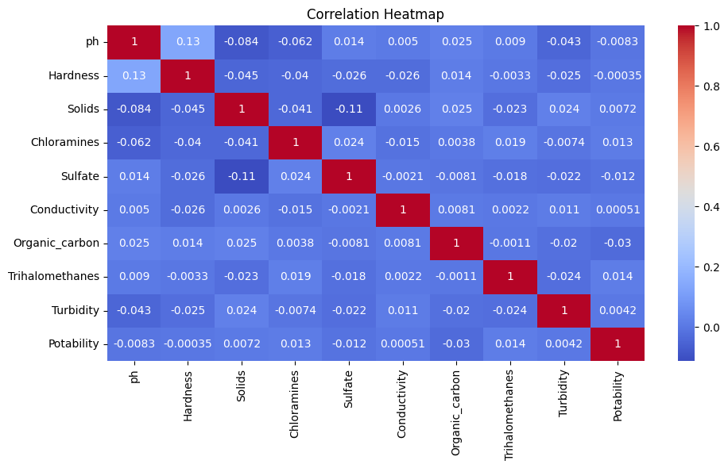
EDA was performed to understand the relationships between different features.
- Heatmaps were used to visualize correlation
- Distribution of features was analysed
- Important features affecting potability were identified

🔹 6.5 Feature Selection
Feature selection involves choosing the most relevant input variables for model training. Selecting appropriate features improves model efficiency and accuracy.
In this project, all physicochemical parameters were considered important and included as input features, as each contributes to determining water quality.
Importance of Feature Selection
- Reduces overfitting
- Improves model performance
- Decreases computational complexity
Proper feature selection ensures that the model focuses only on meaningful data.

🔹 6.6 Model Selection
Selecting the right machine learning model is crucial for achieving high accuracy and performance. In this project, multiple classification algorithms were implemented and compared.
🔸 Models Used:
1. Decision Tree
A simple and interpretable model that makes decisions based on feature conditions.
2. Random Forest
An ensemble model that combines multiple decision trees to improve accuracy and reduce overfitting.
3. K-Nearest Neighbors (KNN)
A distance-based algorithm that classifies data based on similarity with neighboring data points.
4. Support Vector Machine (SVM)
A powerful algorithm that identifies the optimal boundary to separate classes.
Purpose of Model Selection
- To compare performance of different algorithms
- To identify the most accurate model
- To improve prediction reliability

🔹 6.7 Model Training
In this phase, the selected machine learning models are trained using the dataset.
🔸 Process:
- The dataset is divided into training and testing sets
- Training data is used to train the models
- Models learn patterns and relationships between input features and output
Importance of Training
- Enables the model to learn from data
- Builds prediction capability
- Forms the core of the machine learning process

🔹 6.8 Model Testing and Evaluation
After training, the models are tested using unseen data (testing dataset) to evaluate their performance.
🔸 Evaluation Metric:
Accuracy
- Measures the percentage of correct predictions
🔸 Process:
- Models generate predictions on test data
- Predictions are compared with actual values
- Performance is calculated
🔸 Model Comparison:
All models were compared based on accuracy. Among them, the Support Vector Machine (SVM) showed the highest accuracy and best performance.
Conclusion:
SVM was selected as the final model due to its superior prediction capability.
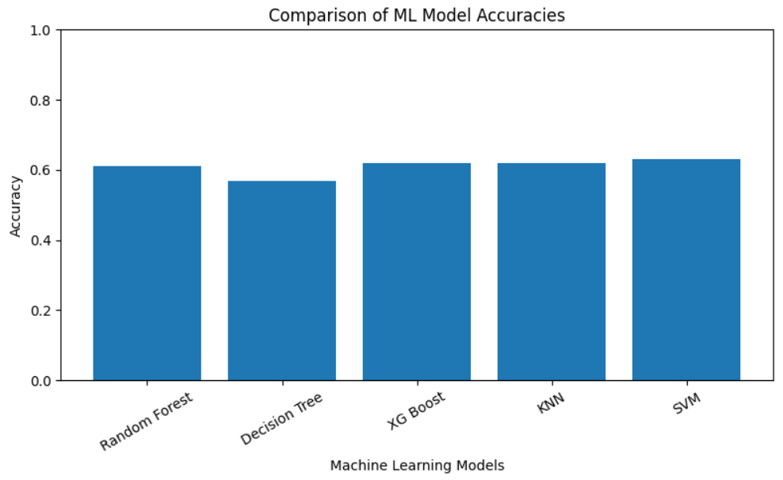
The trained models were evaluated using testing data.
- Accuracy metric was used for evaluation
- Performance of each model was compared
Best model was selected

🔹 6.9 Result Generation
The final output of the system is generated after model evaluation.
🔸 Output Format:
- 1 → Potable (Safe for drinking)
- 0 → Non-potable (Unsafe for drinking)
🔸 Features:
- Fast prediction
- Accurate results
- Easy interpretation
The system provides instant predictions based on input parameters, making it efficient and user-friendly.

DATA FLOW DIAGRAM (DFD)
🔹 6.10 Overview
A Data Flow Diagram (DFD) is a graphical representation that illustrates how data moves through a system. It shows how input data is processed and transformed into output.
🔸 System Flow:
Input Data → Processing → Output
DFD helps in understanding system functionality in a clear and visual manner.

🔹 6.11 Level 0 DFD (Context Diagram)
The Level 0 DFD provides a high-level overview of the system by representing it as a single process.
🔸 Components:
Input:
Water quality dataset (CSV file)
Process:
Machine Learning Model
Output:
Water potability prediction (0 or 1)
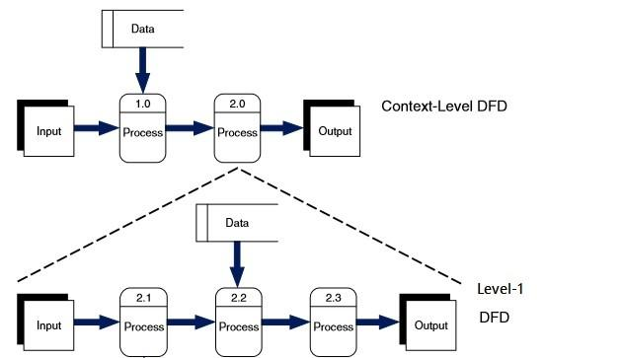
Description:
- Input:
Water quality dataset in CSV format containing various physicochemical parameters such as pH, hardness, solids, chloramines, sulfate, conductivity, organic carbon, trihalomethanes, and turbidity.
- Process:
The Machine Learning model processes the input dataset by analyzing patterns and relationships between different parameters.
- Output:
The system generates the final prediction indicating water potability:
  - 1 → Potable (Safe for drinking)
  - 0 → Non-potable (Unsafe for drinking)
Explanation:
- The user provides input data
- The system processes the data
- The system generates the prediction
This diagram simplifies the system representation for easy understanding.
🔹 6.12 Level 1 DFD (Detailed Diagram)
The Level 1 DFD provides a detailed breakdown of the system into multiple processes.
🔸 Processes:
1. Data Input
Dataset is loaded into the system
2. Data Preprocessing
Missing values handled and data cleaned
3. Feature Selection
Relevant features selected
4. Model Training
Models trained using training data
5. Model Testing
Performance evaluated
6. Prediction Output
Final result generated
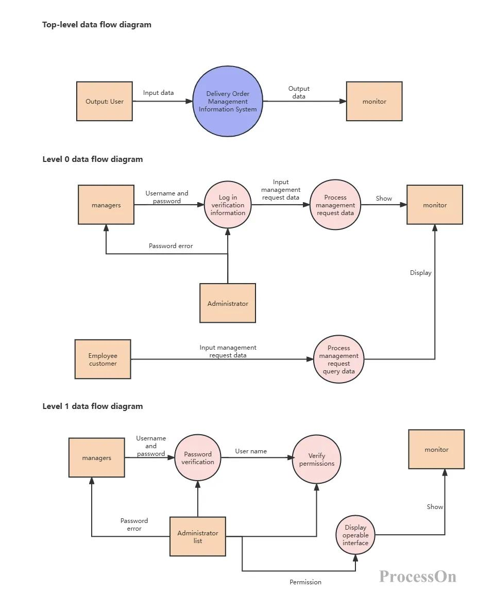
Detailed Processes:
- Data Input:
The system receives the water quality dataset in CSV format. This dataset includes multiple attributes that are used for analysis and prediction.
- Data Preprocessing:
  - Missing values in the dataset are identified and handled appropriately (e.g., replaced with mean values).
  - Data cleaning is performed to remove inconsistencies and ensure data quality.
- Feature Selection:
  - Relevant features (parameters) are selected from the dataset.
  - Irrelevant or less significant attributes may be ignored to improve model performance.
- Model Training:
  - Machine Learning algorithms such as Decision Tree, Random Forest, K-Nearest Neighbors (KNN), and Support Vector Machine (SVM) are applied.
  - The model learns patterns from the training dataset.
- Model Testing:
  - The trained model is evaluated using test data.
  - Performance metrics such as accuracy are calculated to assess model effectiveness.
- Prediction Output:
  - The final output is generated based on the trained model.
  - Output values are:
    - 1 → Potable (Safe for drinking)
    - 0 → Non-potable (Unsafe for drinking)
8. Result Generation
The final output of the system is:
- 1 → Water is safe for drinking
- 0 → Water is not safe for drinking
The system provides quick and efficient prediction based on input parameters.

Advantages of DFD
- Improves system understanding
- Clearly shows data flow
- Helps in debugging and improvement

🔹 6.13 Testing Methodology
Testing ensures that the system works correctly and produces accurate results.
🔸 Types of Testing:
1. Model Testing
Models tested using test dataset
2. Accuracy Testing
Correct predictions calculated
3. Performance Testing
Different models compared

🔹 6.14 Test Report
The performance of different models was analysed and compared.
Model | Performance
Decision Tree | Moderate
Random Forest | High
KNN | Moderate
SVM | Highest

Conclusion:
- SVM performed the best
- Provided the most accurate predictions
🔹 6.15 Conclusion
The project life cycle ensured the systematic development of the water potability prediction system. Each phase, from data collection to result generation, contributed significantly to the success of the project.
The structured approach resulted in:
- High accuracy
- Reliable predictions
- Efficient system design
This project demonstrates the effectiveness of machine learning in solving real-world environmental problems and highlights its potential for future advancements in water quality monitoring

Dash Board & Explanation for the outcome & future steps
Sheet 1.
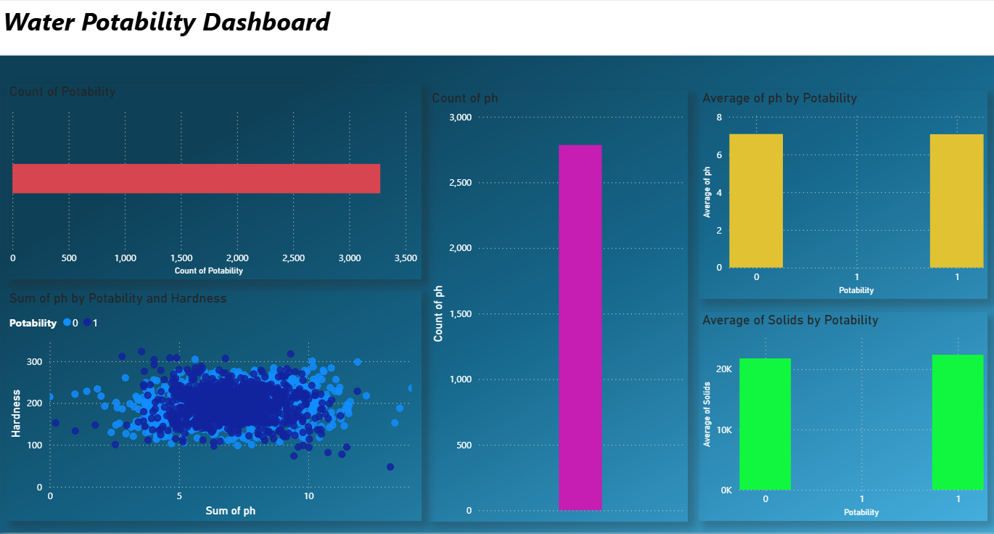

Count of Potability
🔹 Key Highlights:
- Shows the total number of water samples in the dataset
- Represents both potable (1) and non-potable (0) water
- Indicates dataset size and reliability
- Helps understand data availability for analysis
Detailed Explanation:
The Count of Potability graph represents the total number of water samples included in the dataset, combining both potable and non-potable water categories. A high number of samples indicates that the dataset is sufficiently large, which improves the reliability and credibility of analytical results. This graph is important because a larger dataset allows better identification of patterns and relationships between water quality parameters. In the context of water potability, having many observations helps researchers and analysts confidently evaluate factors affecting drinking water safety and supports accurate predictive modeling.
Count of pH
🔹 Key Highlights:
- Displays number of recorded pH values
- Indicates data completeness
- Confirms availability of chemical measurements
- Supports reliable acidity/alkalinity analysis
Detailed Explanation:
The Count of pH graph shows how many water samples contain recorded pH values, which is a critical parameter in determining water quality. The high count visible in the graph suggests that most water samples have valid pH readings, reflecting good data quality and minimal missing values. Since pH measures whether water is acidic, neutral, or alkaline, this parameter plays an essential role in determining water suitability for drinking. Reliable pH data allows analysts to study how water acidity influences potability and ensures that conclusions drawn from the dataset are based on accurate chemical measurements.

Average of pH by Potability
🔹 Key Highlights:
- Compares average pH levels between potable and non-potable water
- Both categories show nearly neutral pH values
- Suggests pH alone may not determine potability
- Indicates need for multi-factor analysis
Detailed Explanation:
The Average of pH by Potability graph compares the mean pH values of potable and non-potable water samples. The bars in the graph show that both types of water generally have pH values close to neutral, around 7. This indicates that even non-potable water may sometimes fall within acceptable pH ranges. Therefore, pH alone is not sufficient to determine whether water is safe for drinking. Other parameters such as hardness, dissolved solids, and contaminants must also be considered. This graph highlights the importance of evaluating multiple chemical properties together to accurately classify water potability.

Sum of pH by Potability and Hardness (Scatter Plot)
🔹 Key Highlights:
- Shows relationship between pH and hardness
- Displays distribution of potable vs non-potable samples
- Indicates overlapping patterns
- Suggests multiple variables influence water quality
Detailed Explanation:
The scatter plot visualizes the relationship between water hardness and pH values while distinguishing between potable and non-potable samples. Each point represents a water sample, and the distribution shows that both potable and non-potable water exist across a wide range of hardness levels. The overlap between the two categories indicates that hardness and pH alone cannot fully determine water safety. Instead, water quality depends on multiple interacting factors. This graph is useful for identifying patterns, detecting clusters, and understanding how mineral content and chemical balance contribute to water potability classification.

Average of Solids by Potability
🔹 Key Highlights:
- Displays average dissolved solids (TDS)
- Compares solid levels in potable vs non-potable water
- Indicates mineral presence in water
- Helps assess water clarity and taste impact
Detailed Explanation:
The Average of Solids by Potability graph shows the average amount of dissolved solids present in potable and non-potable water samples. Dissolved solids include minerals, salts, and organic matter found in water. The graph indicates that potable water may contain slightly higher or comparable levels of dissolved solids compared to non-potable water. This suggests that the presence of minerals alone does not necessarily make water unsafe. However, extremely high levels of solids can negatively affect taste, appearance, and health. This graph helps evaluate acceptable ranges of dissolved materials and their role in determining drinking water quality.
Overall Dashboard Conclusion
🔹 Key Findings:
- Water potability depends on multiple parameters, not a single factor
- pH values are generally neutral across both water categories
- Hardness and dissolved solids vary significantly
- There is overlap between potable and non-potable samples
- Indicates need for advanced analytical methods
Detailed Conclusion:
The Water Potability Dashboard provides valuable insights into the factors influencing water quality and safety. The analysis shows that potable and non-potable water share similar ranges in several parameters, particularly pH values, which remain close to neutral in most cases. However, variations in hardness and dissolved solids highlight the complexity of water quality assessment. The overlap observed in scatter plots suggests that water potability cannot be determined by a single parameter alone. Instead, accurate classification requires analyzing multiple physical and chemical properties simultaneously using statistical or machine learning approaches.

Future Steps and Recommendations
🔹 Suggested Improvements:
1. Add More Parameters
- Include turbidity, conductivity, sulfate, and chloramines
- Improves accuracy of water quality prediction
2. Implement Machine Learning Models
- Apply models such as Random Forest or Decision Tree
- Helps automatically predict water potability
3. Add Threshold Indicators
- Include WHO or BIS safe water limits
- Makes unsafe conditions easy to identify
4. Improve Dashboard Visualization
- Add filters (pH range, hardness range, solids level)
- Makes analysis interactive and user-friendly
5. Perform Correlation Analysis
- Identify strongest relationships between variables
- Helps determine key factors affecting potability
6. Conduct Time-Based Monitoring
- Add historical trend analysis
- Helps detect seasonal or long-term changes

Sheet 2.

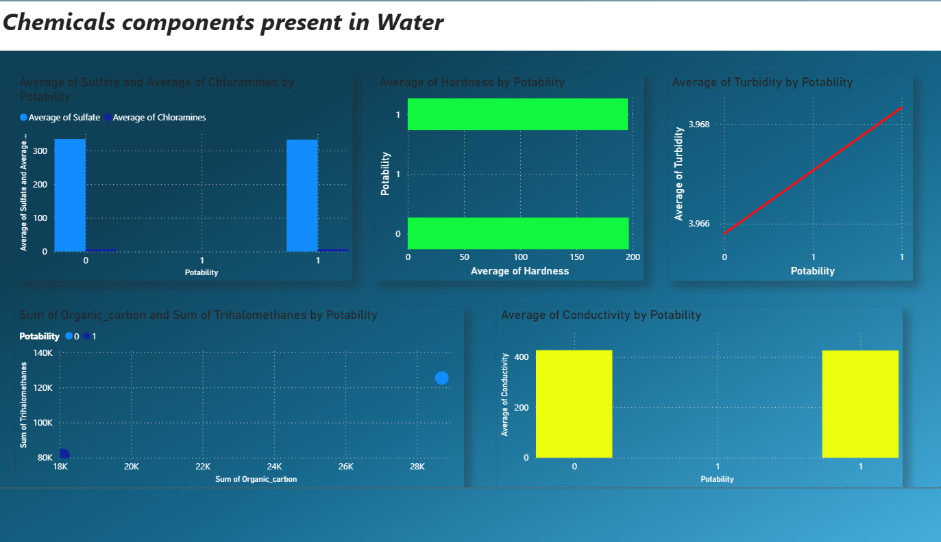

Average of Sulfate and Average of Chloramines by Potability
🔹 Key Highlights:
- Compares average sulfate levels in potable and non-potable water
- Shows chloramine concentration differences
- Indicates chemical treatment presence in water
- Helps assess chemical safety levels
- Useful for identifying possible contamination risks
Detailed Explanation:
This graph compares the average levels of sulfate and chloramines in potable and non-potable water samples. Sulfates are naturally occurring minerals in water, while chloramines are commonly used as disinfectants during water treatment. The graph shows that sulfate levels are relatively similar across both potable and non-potable water samples, suggesting that moderate sulfate presence does not necessarily make water unsafe. Chloramine levels also appear relatively consistent, indicating that controlled chemical treatment may be applied across water samples. However, excessive amounts of either chemical could lead to health concerns such as irritation or digestive issues. This graph helps evaluate whether chemical concentrations remain within acceptable safety limits and supports the monitoring of water treatment effectiveness.

Average of Hardness by Potability
🔹 Key Highlights:
- Shows average hardness levels in water
- Compares mineral content between potable and non-potable water
- Indicates presence of calcium and magnesium minerals
- Helps assess scaling and water usability
- Supports evaluation of water quality suitability
Detailed Explanation:
The Average of Hardness by Potability graph illustrates the mineral content in water samples, specifically calcium and magnesium levels responsible for water hardness. The graph shows similar hardness values in both potable and non-potable water categories, indicating that hardness alone may not determine whether water is safe to drink. Moderate hardness is generally acceptable and may even contribute beneficial minerals to drinking water. However, very high hardness levels can cause scaling in pipes and appliances, affecting water usability. This graph highlights that hardness is an important quality indicator but must be evaluated alongside other chemical parameters when determining water potability.

Average of Turbidity by Potability
🔹 Key Highlights:
- Measures clarity of water samples
- Indicates presence of suspended particles
- Shows slight variation between potable and non-potable water
- Helps detect physical contamination risks
- Supports monitoring of filtration effectiveness
Detailed Explanation:
The Average of Turbidity by Potability graph measures the clarity of water by showing the average turbidity levels in potable and non-potable samples. Turbidity indicates the presence of suspended particles such as dirt, microorganisms, and organic matter. The graph shows only a small difference between potable and non-potable water samples, suggesting that turbidity levels are fairly controlled across the dataset. Although turbidity alone does not determine water safety, high turbidity levels can protect harmful microorganisms from disinfection processes. This graph emphasizes the importance of maintaining low turbidity levels to ensure effective water purification and safe drinking conditions.

Sum of Organic Carbon and Sum of Trihalomethanes by Potability (Scatter Plot)
🔹 Key Highlights:
- Shows relationship between organic carbon and trihalomethanes
- Indicates by-products of water disinfection
- Highlights possible chemical contamination risks
- Shows distribution differences between water types
- Useful for detecting harmful chemical accumulation
Detailed Explanation:
This scatter plot displays the relationship between total organic carbon and trihalomethanes in potable and non-potable water samples. Organic carbon represents natural organic matter present in water, while trihalomethanes are chemical by-products formed when disinfectants react with organic substances. The distribution of points suggests that higher organic carbon levels may lead to increased formation of trihalomethanes, which are potentially harmful if present in excessive amounts. The presence of these compounds highlights the importance of monitoring water treatment processes carefully. This graph demonstrates how chemical interactions during purification can influence overall water safety and quality.

Average of Conductivity by Potability
🔹 Key Highlights:
- Measures water’s electrical conductivity
- Indicates presence of dissolved ions
- Compares mineral concentration between categories
- Helps assess overall water purity
- Supports identification of contaminant levels
Detailed Explanation:
The Average of Conductivity by Potability graph represents the ability of water to conduct electricity, which depends on the concentration of dissolved ions such as salts and minerals. The graph shows similar conductivity values between potable and non-potable water samples, suggesting that dissolved ion levels alone do not fully determine water safety. Moderate conductivity is normal in drinking water, but excessively high levels may indicate contamination from industrial waste or saline sources. This graph helps assess overall mineral concentration and supports quality monitoring efforts aimed at ensuring water remains within safe conductivity limits.

Overall Dashboard Conclusion
🔹 Key Findings:
- Chemical components play a major role in water safety
- Many chemical values appear similar across potable and non-potable water
- Indicates combined effect of multiple chemical parameters
- Shows importance of monitoring treatment by-products
- Highlights need for balanced chemical concentration
Detailed Conclusion:
The Chemicals Components Dashboard provides insights into the chemical properties influencing water potability. The analysis shows that several chemical parameters, including sulfate, chloramines, hardness, turbidity, and conductivity, display similar patterns across potable and non-potable water samples. This suggests that no single chemical factor determines water safety independently. Instead, potability depends on the combined effects of multiple chemical components and their interactions. The presence of organic carbon and trihalomethanes emphasizes the importance of monitoring chemical reactions occurring during water treatment. Overall, this dashboard highlights the complexity of chemical water quality management.
Future Steps and Recommendations
🔹 Suggested Improvements:
1. Add Safety Threshold Lines
- Include WHO or BIS chemical safety limits
- Helps identify unsafe levels visually
2. Perform Chemical Correlation Analysis
- Identify strongest relationships between chemicals
- Helps understand chemical interactions
3. Implement Predictive Modeling
- Use machine learning models to predict potability
- Improves decision-making accuracy
4. Add Risk-Level Indicators
- Use color coding (Green, Yellow, Red)
- Makes unsafe water identification easier
5. Monitor Chemical Trends Over Time
- Add time-series analysis
- Helps detect contamination events early
6. Integrate Real-Time Monitoring Systems
- Connect IoT sensors for live data
- Enables continuous water quality monitoring
Sheet 3.
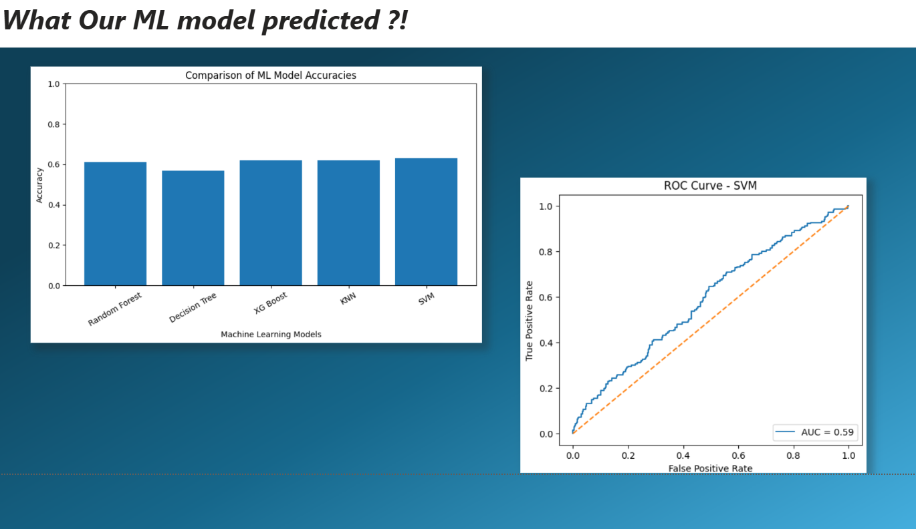

Sheet 4.

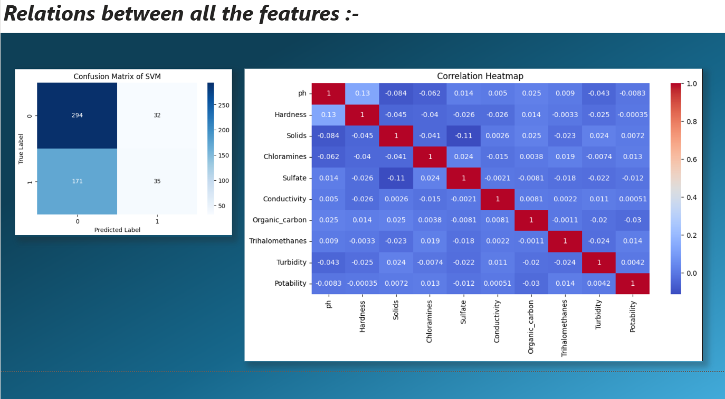

Comparison of ML Model Accuracies
🔹 Key Highlights:
- Compares performance of multiple machine learning models
- Models included: Random Forest, Decision Tree, XGBoost, KNN, and SVM
- SVM shows the highest accuracy among all models
- Decision Tree shows the lowest accuracy
- Indicates overall moderate prediction performance
Detailed Explanation:
This graph compares the accuracy levels of different machine learning models used to predict water potability. The models evaluated include Random Forest, Decision Tree, XGBoost, K-Nearest Neighbors (KNN), and Support Vector Machine (SVM). Among these, the SVM model achieved the highest accuracy, slightly outperforming other models such as XGBoost and KNN. The Decision Tree model shows the lowest performance, suggesting it may not generalize well with this dataset. Overall, the accuracy values appear moderate, indicating that while the models can predict potability reasonably, there is still room for improvement through better feature engineering and tuning.

ROC Curve — Support Vector Machine (SVM)
🔹 Key Highlights:
- Displays ROC curve performance of SVM model
- Shows relationship between True Positive Rate and False Positive Rate
- AUC value is approximately 0.59
- Indicates moderate prediction capability
- Suggests model improvement is needed
Detailed Explanation:
The ROC (Receiver Operating Characteristic) curve visualizes the performance of the Support Vector Machine (SVM) model by plotting the True Positive Rate against the False Positive Rate. The curve lies slightly above the diagonal reference line, indicating that the model performs better than random guessing. The Area Under the Curve (AUC) value is approximately 0.59, which reflects moderate predictive performance. Ideally, an AUC value closer to 1 indicates a strong model. Therefore, this graph suggests that although the SVM model performs better than some alternatives, further optimization and feature refinement are required to enhance classification accuracy.
Overall Machine Learning Dashboard Conclusion
🔹 Key Findings:
- Multiple ML models were tested for prediction
- SVM performed best among tested models
- Overall accuracy levels are moderate (~60–64%)
- ROC curve confirms average classification ability
- Indicates need for further model optimization
Detailed Conclusion:
The Machine Learning Prediction Dashboard highlights the comparative performance of multiple classification algorithms used to predict water potability. Among the tested models, Support Vector Machine achieved the highest accuracy, making it the best-performing model in this experiment. However, the ROC curve analysis indicates an AUC value of approximately 0.59, suggesting only moderate predictive capability. This implies that while the models are capable of identifying patterns in water quality data, they require further optimization to achieve stronger predictive performance. Improving feature selection, balancing the dataset, and tuning hyperparameters could significantly enhance model effectiveness.

Confusion Matrix of SVM
🔹 Key Highlights:
- Shows actual vs predicted classifications of the SVM model
- Correct predictions for non-potable water (0) are high
- False negatives are relatively large (potable predicted as non-potable)
- Indicates model bias toward non-potable prediction
- Helps evaluate classification reliability
Detailed Explanation:
The Confusion Matrix of the Support Vector Machine (SVM) model illustrates how accurately the model predicted potable and non-potable water samples. The matrix shows that a large number of non-potable samples were correctly classified, indicating strong performance in identifying unsafe water. However, the number of false negatives, where potable water was incorrectly classified as non-potable, is relatively high. This suggests that the model is slightly biased toward predicting water as unsafe. The confusion matrix is essential for evaluating classification performance beyond accuracy and understanding where prediction errors occur.

Correlation Heatmap of All Features
🔹 Key Highlights:
- Displays relationships between all water quality parameters
- Most correlations are weak (close to zero)
- Slight positive correlation between pH and Hardness
- Shows minimal direct correlation with Potability
- Indicates complex multi-factor dependency
Detailed Explanation:
The Correlation Heatmap visualizes the relationships between all water quality parameters, including pH, hardness, solids, chloramines, sulfate, conductivity, organic carbon, trihalomethanes, turbidity, and potability. Most values in the heatmap are close to zero, indicating weak relationships between individual variables. A slight positive correlation between pH and hardness suggests that these two features may vary together to some extent. However, potability shows very weak direct correlation with individual features, indicating that water safety depends on the combined interaction of multiple parameters rather than any single variable alone.

Overall Dashboard Conclusion
🔹 Key Findings:
- SVM model predicts non-potable water more accurately
- Some misclassification exists, especially false negatives
- Most features show weak individual correlation
- Potability depends on combined multi-feature interaction
- Indicates need for feature engineering and model tuning

Detailed Conclusion:
This dashboard provides insights into both model performance and relationships among water quality features. The confusion matrix shows that the SVM model performs reasonably well in detecting non-potable water but struggles to correctly classify some potable samples. Meanwhile, the correlation heatmap indicates that most water quality features have weak direct relationships with potability, suggesting that water safety depends on multiple interacting variables rather than individual measurements. These observations highlight the complexity of predicting water potability and emphasize the importance of improving feature selection, engineering new variables, and optimizing machine learning models.

